*Florida International University*

*School of Computing and Information Sciences*

CIS 4911 - Senior Capstone Project

Software Engineering Focus

Final Deliverable

**Smart Systems for Occupancy and Building Energy Control (SSOBEC) Version 2**

**Team Members**

Diana Leante Boné

Irvin S. Cardenas

**Product Owner**: Dr. Leonardo Bobadilla, Dr. Ali Mostafavi

**Instructor**: Dr. Masoud Sadjadi

***Abstract***

The Smart System for Occupancy and Building Energy Control is an application designed to teach people how to save energy. The Smart Building App provides information on occupancy behavior and energy consumption within different zones of a building. The information displayed on the application can help users to become energy literate and to learn to use electricity in an efficient way. The data shown is specific to each zone, allowing for a personalized means to save energy. As a result, users can improve their energy consumption behavior and save electricity in each zone by using the information shown in the app.

Table of Contents

**Introduction** 4

Current System 4

Purpose of New System 4

Implemented User Stories 6

Pending User Stories 11

**Project Plan** 12

Hardware and Software Resources 12

Sprints Plan 13

Sprint 1 13

Sprint 2 16

Sprint 3 19

Sprint 4 22

Sprint 5 25

**System Design** 28

Architectural Patterns 28

System and Subsystem Decomposition 29

Deployment Diagram 31

Design Patterns 31

**System Validation** 32

**Glossary** 57

**Appendix** 58

Appendix A - UML Diagrams 58

Static UML Diagrams 58

Dynamic UML Diagrams 59

Appendix B - User Interface Design 65

Appendix C - Sprint Review Reports 84

Appendix D - Sprint Retrospective Reports 86

**References** 88

# **Introduction**

This section describes the current system established for the Smart System for Occupancy and Building Energy Control application and its characteristics. It explains the purpose of the new system to be developed which will include additional features to improve the current system. The implemented user stories for the Smart Building app are detailed as well as the pending user stories to be developed in future releases.

This document gives an overview of the Smart System for Occupancy and Building Energy Control application. The Project Plan section contains the description of the Hardware and Software resources used and the Sprint Plan carried out. The System Design describes the Architectural Patterns, the System and Subsystem Decomposition, the Deployment Diagram and the Design Patterns using UML diagrams. The System Validation contains the test cases used to verify the Smart Building App features. The Glossary defines any domain-specific terms for the readers of this document. The Appendix contains the static and dynamic UML Diagrams, screenshots of the User Interface Design, the Sprint Review Reports and the Sprint Retrospective Reports. The last section is the References section which mentions the works cited within this document.

## Current System

In the current system, a user can measure how much energy is consumed only after he/she reads the utility bills of each month. The current system does not provide a smart approach to compare energy consumption of the zones in a building along with occupancy behavior of the people in the different zones of the building. The user does not know which rooms consume more energy than others or which rooms waste more energy when they are left empty and electricity is being used.

A user can see the total amount of energy consumed but is unable to see the appliances that were connected during that time period or the consumption of each appliance. The user can see the amount of energy usage there has been for a period but cannot identify how much of that energy was not consumed efficiently. Moreover, the current system does not allow for statistical analysis of energy consumption in different zones and the user is limited to the energy consumption data of the entire building or residence.

## Purpose of New System

The Smart Systems for Occupancy and Building Energy Control is an Android application that allows users to view energy consumption information on an Android mobile device. The SSOBEC application will allow the role of facility manager as well as general user. The facility manager will have additional features as well as the capabilities of a general user of the app. The existence of a facility manager role will permit the monitoring of all zones in the building. Some of the additional features for a facility manger will include being able to create a zone with location and number of windows information within the app. The facility manager will be able to add a user to a zone and remove a user from a zone which will allow the manager to setup users’ subscription to specific zones in the building. The facility manager will also be able to get report for all zones energy consumption, get report for User Rewards and view suggestions based on the plug-load energy consumption for all the zones of the building. These functionalities will satisfy the purpose of giving a facility manager a more comprehensive role in the building and allowing for statistical analysis of energy consumption data by zone.

The general user of the app will also enjoy multiple capabilities that will allow him to monitor his zones’ consumption and increase his energy savings. Among the functionalities added will be to Add Appliance to a Zone which will permit any user to update appliance information and to edit a Zone which will allow users to edit zone information from an already existing zone. The general user will also be able to View Wasteful Regions including zones where the light was left on with no occupants inside. The user will have the functionalities of Turning Light Off in a wasteful region, Turning Appliance Off in a Wasteful Region, and Notify Users of Wasteful Regions through an email message. The user will earn Reward Points for using these last features which aid in saving energy in the building. The general user will also be able to View User Rewards, get energy consumption report for his Zones, get report for User Rankings based on Reward Points, and view personalized feedback suggestions based on the users’ zones consumption in order to improve his energy performance.

All these features will facilitate the main purpose of the application which is to help users have more control over their energy consumption so that they may become more energy efficient and increase their energy savings.

**User Stories**

The following section describes the user stories obtained through the meetings with the product owners and reflects the focus of the SSOBEC application and the features that were discussed in the development of the app. The implemented user stories include all the user stories implemented in the current version of the system. The pending user stories section contains the stories not implemented that were carried over from previous versions of the system or that were created during this version but not implemented.

## Implemented User Stories

**User Story** [**#497**](https://fiu-scis-seniorproject.mingle.thoughtworks.com/projects/smart_building/cards/497)**- Create Facility Manager View**

***User Story Description*:** As a facility manager, I should be able to login to access the facility manager view so that I can manage the building zones.

***Acceptance Criteria***

1. The facility manager should be able to login similarly to a general user.
2. Once the facility manager credentials are validated, the system should display the facility manager view which includes the zones for the facility manager and the features allowed for a facility manager.

**User Story #** [**499**](https://fiu-scis-seniorproject.mingle.thoughtworks.com/projects/smart_building/cards/499)**- Allow Facility Manager to create a Zone**

***User Story Description*:** As a facility manager, I should be able to create a Zone from the App so that there is no need to access the back-end directly.

***Acceptance Criteria***

1. Once the Zone is created by the facility manager, it should be available for users to add the zone.

**User Story #498 - Create general user view**

***User Story Description*:** As a general user, I should be able to login to access the general user view so that I can view my zones within the building.

***Acceptance Criteria***

1. Once the general user credentials are validated, a general user should be able to login and view his zone

**User Story** [**#500**](https://fiu-scis-seniorproject.mingle.thoughtworks.com/projects/smart_building/cards/500)**- Allow User to unfollow a zone**

***User Story Description:*** As a general user, I should be able to unfollow a zone that is already in my profile so that I can stop viewing zones that I am not interested in anymore.

***Acceptance Criteria***

1. Once the user unfollows a zone, it should not be displayed in his “My Zones” activity.
2. The database should be properly updated so that the user is not linked to the unfollowed zone.
3. Once the general user credentials are validated, a general user should be able to login and view his zone.

**User Story # 512 – View Account Reward Points**

***User Story Description*:** As a general user, I should be able to see my reward points so that I can see the points I have earned for saving energy.

***Acceptance Criteria***

1. The user needs to be able to see the number of points he/she has earned in total.
2. The information on the reward points needs to be given in real time.

**User Story # 510 – View Wasteful Regions**

***User Story Description*:** As a user, I should be able to see the regions that are currently being wasteful depending on their energy consumption and whether the lights are on with no occupancy in the region.

***Acceptance Criteria***

1. The user needs to be able to see the list of regions that are currently wasting energy due to lights on with no occupancy in the region, or energy consumption.
2. The energy information used to determine the wasteful regions needs to be based on real time.

**User Story # 513 – Allow Facility Manager to edit a Zone**

***User Story Description*:** As a facility manager, I should be able edit a zone that has already been created so that I can update changes made to an existing zone.

***Acceptance Criteria***

1. The facility manager needs to be able to visualize/identify the zone that he she wants to edit and see the current attributes of the zone in real time.
2. Once the facility manager applies the changes, the zone attributes should be updated and displayed with the new changes

**User Story # 515 – Allow User to add appliances to Zone**

***User Story Description*:** As a general user, I should be able to add an appliance to a zone that has already been created so that the appliance used in the zone can be linked to the energy consumption information of the zone.

***Acceptance Criteria***

1. The general user needs to be able to visualize/identify the zone that he/she will be adding appliances to and needs to be able to see the current appliances in the zone in real time.
2. Once the user adds the appliance, he/she should be able to see the updated list of all the appliances in the zone.

**User Story # 511 - Turn off Light in Wasteful Region and earn points**

***User Story Description*:** As a user, I should be able to turn off light in a wasteful region that has no occupants and earn reward points so that I may save energy and be rewarded for energy efficient behavior.

***Acceptance Criteria***

1. The user should be able to identify which wasteful region he/she is turning the light off.
2. The system shall reward the user with points for saving energy.
3. The user should be able to see the points earned, once he/she has turned off the light.

**User Story # 568 - Turn off Appliance in Wasteful Region and earn points**

***User Story Description*:** As a user, I should be able to turn off an appliance in a wasteful region and earn reward points so that I may save energy and be rewarded for energy efficient behavior.

***Acceptance Criteria***

1. The user should be able to identify which wasteful region he/she is turning the appliance off.
2. The system shall reward the user with points for saving energy.
3. The user should be able to see the points earned, once he/she has turned off the appliance.

**User Story # 514 - Allow Facility Manager to add Users to existing Zone**

***User Story Description*:** As a facility manager, I should be able to add a user to a zone that has already been created so that the user can have that zone added to his view of zones.

***Acceptance Criteria***

1. The facility manager needs to be able to visualize/identify the zone that he will be adding users to.
2. Once the facility manager adds the user, the database should be updated so that the user added has access to the zone data.

**User Story # 571 - Allow Facility Manager to remove Users from existing Zone**

***User Story Description*:** As a facility manager, I should be able to remove a user from a zone that has already been created so that the user does not have access to the zone information in his view of zones.

***Acceptance Criteria***

1. The facility manager needs to be able to visualize/identify the zone that he will be removing a user from.
2. Once the facility manager removes the user, the database should be updated so that the user does not have access to the zone data.

**User Story #601 - Generate User statistic reports**

***User Story Description*:** As a facility manager I should be able to see a summary of the users statistics so that I can compare and learn which users earn more rewards by saving energy.

***Acceptance Criteria***

1. The facility manager should be able to see the names of the users.
2. The facility manager should be able to visualize the rewards earned by the users.

**User Story #602 – Generate Zone statistics reports**

***User Story Description*:** As a facility manager I should be able to see a summary of the usage statistics for all zones so that I can compare the zones and see which zones are consuming more energy.

***Acceptance Criteria***

1. The facility manager can see the names of the zones.
2. The zones data is displayed in a visual context suitable for comparison such as a graph.

**User Story #570 - Notify users of wasteful regions**

***User Story Description*:** As a user, I should be able to use the application to notify the users of wasteful regions so that the users/followers of the wasteful region can be reminded to save energy by turning off lights or appliances.

***Acceptance Criteria***

1. The user should see the emails of the users that will be getting the notifications.

**User Story #603 – Allow users to earn points by sending notifications**

***User Story Description*:** As a general user, I should be able to earn points when I send notifications through the app to turn off lights in regions with no occupants or to reduce energy consumption in highly consuming regions, so that I can be rewarded for reminding others to be energy efficient.

***Acceptance Criteria***

1. The user should see the number of points to be earned.

**User Story #604 – Provide personalized feedback suggestions**

***User Story Description*:** As a user I should be able to see suggestions to save energy so that I may reduce consumption in my zones.

***Acceptance Criteria***

1. The user should see a comparison of his zones energy performance with the average performance of the zones in the building.
2. The user should see suggestions depending on his\her zones energy performance.

**User Story #605 - Provide user rankings**

***User Story Description*:** As a general user, I should be able to see what my rank is for User Reward Points so that I may compare to other users.

***Acceptance Criteria***

1. The user should see his\her rank and the Total Reward Points.

**User Story #625 – Refine Final Document**

***User Story Description*:** Refine Final Document.

***Acceptance Criteria***

1. Refine final document and check UML diagrams.

**User Story #626 – Create User Manual**

***User Story Description*:** As a general user or facility manager user, I should be able to have a User Manual so that I may have instructions for the features of the application.

***Acceptance Criteria***

1. The User Manual must contain the updated screenshots of the application and new features.

## Pending User Stories

**User Story # 224 – View Zone Details Defect**

***User Story Description*:** As a user, I want to identify the important details about a specific zone that affects the energy performance of that zone (e.g. how many windows the zone has, how many appliances) so that I can observe the many ways there is energy consumption in a zone.

***Acceptance Criteria:***

1. These details are to be taken into account when measuring the energy performance of the zone.

**User Story # 569 – Fix View Zone Occupancy Defect**

***User Story Description*:** As a user, I need to be able to see the occupancy of the zone selected so that I can determine whether the zone has occupants or not.

***Acceptance Criteria:***

1. The user should see the number of occupants currently in the room and this data should match with the graph view presented.

# 

# **Project Plan**

This section contains the project plan for the development of the Smart Systems for Occupancy and Building Energy Control (SSOBEC). Included within the plan, we have listed the Hardware and Software resources used to setup, test and improve the SSOBEC mobile application as well as the auxiliary tools used to document the project and to maintain version control for the team through the use of hosted repositories. The Sprint Plan details the user stories that were implemented during each sprint with their corresponding list of tasks to accomplish the story and the acceptance criteria for the user stories.

## Hardware and Software Resources

This section lists in detail the hardware and software used to develop the SSOBEC mobile application as well as the tools used to help the team document the project and maintain version control of the application as it was further developed and enhanced.

**HARDWARE**

* Computer that has a 1.6 GHz or faster processor
* 1GB(32 Bit) RAM
* 3GB of available hard disk space
* Mobile phone with Android
* Tablet with Android

**SOFTWARE**

* Git
* GitHub
* Google Drive
* Gmail
* Android Studio
* Mingle
* StarUML
* SQL
* PHPMyAdmin
* Source Tree
* Camtasia
* Gimp
* Notepad++
* SqliteBrowser
* Putty
* Vertabelo
* Visio 2013
* LAMP
* Espresso

## Sprints Plan

Listed below are the user stories selected for implementation for each sprint in descending order of priority.

### Sprint 1

(05/15/2015 - 05/29/2015)

**User Story** [**#497**](https://fiu-scis-seniorproject.mingle.thoughtworks.com/projects/smart_building/cards/497)**- Create Facility Manager View**

***User Story Description*:** As a facility manager, I should be able to login to access the facility manager view so that I can manage the building zones.

***Tasks***

|  |  |
| --- | --- |
| **Number** | **Name** |
| [529](https://fiu-scis-seniorproject.mingle.thoughtworks.com/projects/smart_building/cards/529) | [Modify the DataAccessUser](https://fiu-scis-seniorproject.mingle.thoughtworks.com/projects/smart_building/cards/529) |
| [526](https://fiu-scis-seniorproject.mingle.thoughtworks.com/projects/smart_building/cards/526) | [Modify My Zones Activity](https://fiu-scis-seniorproject.mingle.thoughtworks.com/projects/smart_building/cards/526) |
| [524](https://fiu-scis-seniorproject.mingle.thoughtworks.com/projects/smart_building/cards/524) | [Modify Login Activity](https://fiu-scis-seniorproject.mingle.thoughtworks.com/projects/smart_building/cards/524) |
| [523](https://fiu-scis-seniorproject.mingle.thoughtworks.com/projects/smart_building/cards/523) | [Modify internal DB](https://fiu-scis-seniorproject.mingle.thoughtworks.com/projects/smart_building/cards/523) |
| [521](https://fiu-scis-seniorproject.mingle.thoughtworks.com/projects/smart_building/cards/521) | [Create Facility Manager layout View](https://fiu-scis-seniorproject.mingle.thoughtworks.com/projects/smart_building/cards/521) |
| [518](https://fiu-scis-seniorproject.mingle.thoughtworks.com/projects/smart_building/cards/518) | [Modify the login php file](https://fiu-scis-seniorproject.mingle.thoughtworks.com/projects/smart_building/cards/518) |
| [517](https://fiu-scis-seniorproject.mingle.thoughtworks.com/projects/smart_building/cards/517) | [Modify Database](https://fiu-scis-seniorproject.mingle.thoughtworks.com/projects/smart_building/cards/517) |
| [516](https://fiu-scis-seniorproject.mingle.thoughtworks.com/projects/smart_building/cards/516) | [Refine Final Document](https://fiu-scis-seniorproject.mingle.thoughtworks.com/projects/smart_building/cards/516) |

***Acceptance Criteria***

1. The facility manager should be able to login similarly to a general user.
2. Once the facility manager credentials are validated, the system should display the facility manager view which includes the zones for the facility manager and the features allowed for a facility manager.

***Modeling***

Refer to UML diagrams in Appendix A that were created or modified to model the functionality that will be implemented in this sprint.

**User Story #** [**499**](https://fiu-scis-seniorproject.mingle.thoughtworks.com/projects/smart_building/cards/499)**- Allow Facility Manager to create a Zone**

***User Story Description*:** As a facility manager, I should be able to create a Zone from the App so that there is no need to access the back-end directly.

***Tasks***

|  |  |
| --- | --- |
| **Number** | **Name** |
| [538](https://fiu-scis-seniorproject.mingle.thoughtworks.com/projects/smart_building/cards/538) | [Modify Database](https://fiu-scis-seniorproject.mingle.thoughtworks.com/projects/smart_building/cards/538) |
| [537](https://fiu-scis-seniorproject.mingle.thoughtworks.com/projects/smart_building/cards/537) | [Modify internal DB](https://fiu-scis-seniorproject.mingle.thoughtworks.com/projects/smart_building/cards/537) |
| [536](https://fiu-scis-seniorproject.mingle.thoughtworks.com/projects/smart_building/cards/536) | [Make new php file to create zone](https://fiu-scis-seniorproject.mingle.thoughtworks.com/projects/smart_building/cards/536) |
| [532](https://fiu-scis-seniorproject.mingle.thoughtworks.com/projects/smart_building/cards/532) | [Make new activity to create zone](https://fiu-scis-seniorproject.mingle.thoughtworks.com/projects/smart_building/cards/532) |
| [531](https://fiu-scis-seniorproject.mingle.thoughtworks.com/projects/smart_building/cards/531) | [Refactor facility manager view to Create Zone](https://fiu-scis-seniorproject.mingle.thoughtworks.com/projects/smart_building/cards/531) |
| [522](https://fiu-scis-seniorproject.mingle.thoughtworks.com/projects/smart_building/cards/522) | [Refine Final Document](https://fiu-scis-seniorproject.mingle.thoughtworks.com/projects/smart_building/cards/522) |

***Acceptance Criteria***

1. Once the Zone is created by the facility manager, it should be available for users to add the zone.

***Modeling***

Refer to UML diagrams in Appendix A that were created or modified to model the functionality that will be implemented in this sprint.

**User Story #498 - Create general user view**

***User Story Description*:** As a general user, I should be able to login to access the general user view so that I can view my zones within the building.

***Tasks***

|  |  |
| --- | --- |
| **Number** | **Name** |
| [543](https://fiu-scis-seniorproject.mingle.thoughtworks.com/projects/smart_building/cards/543) | [Redesign GridLayout](https://fiu-scis-seniorproject.mingle.thoughtworks.com/projects/smart_building/cards/543) |
| [542](https://fiu-scis-seniorproject.mingle.thoughtworks.com/projects/smart_building/cards/542) | [Refactor GridView adapter](https://fiu-scis-seniorproject.mingle.thoughtworks.com/projects/smart_building/cards/542) |
| [539](https://fiu-scis-seniorproject.mingle.thoughtworks.com/projects/smart_building/cards/539) | [Modify PHP Login](https://fiu-scis-seniorproject.mingle.thoughtworks.com/projects/smart_building/cards/539) |
| [530](https://fiu-scis-seniorproject.mingle.thoughtworks.com/projects/smart_building/cards/530) | [Modify Database](https://fiu-scis-seniorproject.mingle.thoughtworks.com/projects/smart_building/cards/530) |
| [525](https://fiu-scis-seniorproject.mingle.thoughtworks.com/projects/smart_building/cards/525) | [Refactor and Design General User Rewards View and Buttons](https://fiu-scis-seniorproject.mingle.thoughtworks.com/projects/smart_building/cards/525) |
| [519](https://fiu-scis-seniorproject.mingle.thoughtworks.com/projects/smart_building/cards/519) | [Refine Final Document](https://fiu-scis-seniorproject.mingle.thoughtworks.com/projects/smart_building/cards/519) |

***Acceptance Criteria***

1. Once the general user credentials are validated, a general user should be able to login and view his zone

***Modeling***

Refer to UML diagrams in Appendix A that were created or modified to model the functionality that will be implemented in this sprint.

**User Story** [**#500**](https://fiu-scis-seniorproject.mingle.thoughtworks.com/projects/smart_building/cards/500)**- Allow User to unfollow a zone**

***User Story Description:*** As a general user, I should be able to unfollow a zone that is already in my profile so that I can stop viewing zones that I am not interested in anymore.

***Tasks***

|  |  |
| --- | --- |
| **Number** | **Name** |
| [541](https://fiu-scis-seniorproject.mingle.thoughtworks.com/projects/smart_building/cards/541) | [Modify Android UI and Database Adapaters](https://fiu-scis-seniorproject.mingle.thoughtworks.com/projects/smart_building/cards/541) |
| [540](https://fiu-scis-seniorproject.mingle.thoughtworks.com/projects/smart_building/cards/540) | [Develop Android Database Logic](https://fiu-scis-seniorproject.mingle.thoughtworks.com/projects/smart_building/cards/540) |
| [528](https://fiu-scis-seniorproject.mingle.thoughtworks.com/projects/smart_building/cards/528) | [Develop PHP and server database logic](https://fiu-scis-seniorproject.mingle.thoughtworks.com/projects/smart_building/cards/528) |
| [527](https://fiu-scis-seniorproject.mingle.thoughtworks.com/projects/smart_building/cards/527) | [Refactor and Design Actionbar and User View](https://fiu-scis-seniorproject.mingle.thoughtworks.com/projects/smart_building/cards/527) |
| [520](https://fiu-scis-seniorproject.mingle.thoughtworks.com/projects/smart_building/cards/520) | [Refine Final Document](https://fiu-scis-seniorproject.mingle.thoughtworks.com/projects/smart_building/cards/520) |

***Acceptance Criteria***

1. Once the user unfollows a zone, it should not be displayed in his “My Zones” activity.
2. The database should be properly updated so that the user is not linked to the unfollowed zone.
3. Once the general user credentials are validated, a general user should be able to login and view his zone.

***Modeling***

Refer to UML diagrams in Appendix A that were created or modified to model the functionality that will be implemented in this sprint.

### Sprint 2

(05/29/2015 - 06/12/2015)

**User Story # 512 – View Account Reward Points**

***User Story Description*:** As a general user, I should be able to see my reward points so that I can see the points I have earned for saving energy.

***Tasks***

|  |  |
| --- | --- |
| **Number** | **Name** |
| [552](https://fiu-scis-seniorproject.mingle.thoughtworks.com/projects/smart_building/cards/552) | [Refactor access to internal database](https://fiu-scis-seniorproject.mingle.thoughtworks.com/projects/smart_building/cards/552) |
| [551](https://fiu-scis-seniorproject.mingle.thoughtworks.com/projects/smart_building/cards/551) | [Create php file to access rewards table](https://fiu-scis-seniorproject.mingle.thoughtworks.com/projects/smart_building/cards/551) |
| [550](https://fiu-scis-seniorproject.mingle.thoughtworks.com/projects/smart_building/cards/550) | [Design layout to view user rewards](https://fiu-scis-seniorproject.mingle.thoughtworks.com/projects/smart_building/cards/550) |
| [549](https://fiu-scis-seniorproject.mingle.thoughtworks.com/projects/smart_building/cards/549) | [Create database table for user rewards](https://fiu-scis-seniorproject.mingle.thoughtworks.com/projects/smart_building/cards/549) |
| [548](https://fiu-scis-seniorproject.mingle.thoughtworks.com/projects/smart_building/cards/548) | [Create Activity to View Rewards](https://fiu-scis-seniorproject.mingle.thoughtworks.com/projects/smart_building/cards/548) |
| [544](https://fiu-scis-seniorproject.mingle.thoughtworks.com/projects/smart_building/cards/544) | [Refine Final Document](https://fiu-scis-seniorproject.mingle.thoughtworks.com/projects/smart_building/cards/544) |

***Acceptance Criteria***

1. The user needs to be able to see the number of points he/she has earned in total.
2. The information on the reward points needs to be given in real time.

***Modeling***

Refer to UML diagrams in Appendix A that were created or modified to model the functionality that will be implemented in this sprint.

**User Story # 510 – View Wasteful Regions**

***User Story Description*:** As a user, I should be able to see the regions that are currently being wasteful depending on their energy consumption and whether the lights are on with no occupancy in the region.

***Tasks***

|  |  |
| --- | --- |
| **Number** | **Name** |
| [562](https://fiu-scis-seniorproject.mingle.thoughtworks.com/projects/smart_building/cards/562) | [Develop logic to get wasteful regions](https://fiu-scis-seniorproject.mingle.thoughtworks.com/projects/smart_building/cards/562) |
| [555](https://fiu-scis-seniorproject.mingle.thoughtworks.com/projects/smart_building/cards/555) | [Create php file to get wasteful regions](https://fiu-scis-seniorproject.mingle.thoughtworks.com/projects/smart_building/cards/555) |
| [554](https://fiu-scis-seniorproject.mingle.thoughtworks.com/projects/smart_building/cards/554) | [Design layout to view wasteful regions](https://fiu-scis-seniorproject.mingle.thoughtworks.com/projects/smart_building/cards/554) |
| [553](https://fiu-scis-seniorproject.mingle.thoughtworks.com/projects/smart_building/cards/553) | [Create Activity to View Wasteful Regions](https://fiu-scis-seniorproject.mingle.thoughtworks.com/projects/smart_building/cards/553) |
| [545](https://fiu-scis-seniorproject.mingle.thoughtworks.com/projects/smart_building/cards/545) | [Refine Final Document](https://fiu-scis-seniorproject.mingle.thoughtworks.com/projects/smart_building/cards/545) |

***Acceptance Criteria***

1. The user needs to be able to see the list of regions that are currently wasting energy due to lights on with no occupancy in the region, or energy consumption.
2. The energy information used to determine the wasteful regions needs to be based on real time.

***Modeling***

Refer to UML diagrams in Appendix A that were created or modified to model the functionality that will be implemented in this sprint.

**User Story # 513 – Allow Facility Manager to edit a Zone**

***User Story Description*:** As a facility manager, I should be able edit a zone that has already been created so that I can update changes made to an existing zone.

***Tasks***

|  |  |
| --- | --- |
| **Number** | **Name** |
| [561](https://fiu-scis-seniorproject.mingle.thoughtworks.com/projects/smart_building/cards/561) | [Modify PHP Database logic](https://fiu-scis-seniorproject.mingle.thoughtworks.com/projects/smart_building/cards/561) |
| [560](https://fiu-scis-seniorproject.mingle.thoughtworks.com/projects/smart_building/cards/560) | [Develop Android Logic to Save Zone Edits](https://fiu-scis-seniorproject.mingle.thoughtworks.com/projects/smart_building/cards/560) |
| [559](https://fiu-scis-seniorproject.mingle.thoughtworks.com/projects/smart_building/cards/559) | [Design UI to View and Edit a Zone](https://fiu-scis-seniorproject.mingle.thoughtworks.com/projects/smart_building/cards/559) |
| [558](https://fiu-scis-seniorproject.mingle.thoughtworks.com/projects/smart_building/cards/558) | [Limit Access Permission to Modify Zones](https://fiu-scis-seniorproject.mingle.thoughtworks.com/projects/smart_building/cards/558) |
| [557](https://fiu-scis-seniorproject.mingle.thoughtworks.com/projects/smart_building/cards/557) | [Design Edit Zone ListView](https://fiu-scis-seniorproject.mingle.thoughtworks.com/projects/smart_building/cards/557) |
| [556](https://fiu-scis-seniorproject.mingle.thoughtworks.com/projects/smart_building/cards/556) | [Refactor DB Zones Description Table](https://fiu-scis-seniorproject.mingle.thoughtworks.com/projects/smart_building/cards/556) |
| [546](https://fiu-scis-seniorproject.mingle.thoughtworks.com/projects/smart_building/cards/546) | [Refine Final Document](https://fiu-scis-seniorproject.mingle.thoughtworks.com/projects/smart_building/cards/546) |

***Acceptance Criteria***

1. The facility manager needs to be able to visualize/identify the zone that he she wants to edit and see the current attributes of the zone in real time.
2. Once the facility manager applies the changes, the zone attributes should be updated and displayed with the new changes

***Modeling***

Refer to UML diagrams in Appendix A that were created or modified to model the functionality that will be implemented in this sprint.

**User Story # 515 – Allow User to add appliances to Zone**

***User Story Description*:** As a general user, I should be able to add an appliance to a zone that has already been created so that the appliance used in the zone can be linked to the energy consumption information of the zone.

***Tasks***

|  |  |
| --- | --- |
| **Number** | **Name** |
| [567](https://fiu-scis-seniorproject.mingle.thoughtworks.com/projects/smart_building/cards/567) | [Develop logic to store appliances added](https://fiu-scis-seniorproject.mingle.thoughtworks.com/projects/smart_building/cards/567) |
| [566](https://fiu-scis-seniorproject.mingle.thoughtworks.com/projects/smart_building/cards/566) | [Create Activity to add appliances to a zone](https://fiu-scis-seniorproject.mingle.thoughtworks.com/projects/smart_building/cards/566) |
| [565](https://fiu-scis-seniorproject.mingle.thoughtworks.com/projects/smart_building/cards/565) | [Design UI to add appliances](https://fiu-scis-seniorproject.mingle.thoughtworks.com/projects/smart_building/cards/565) |
| [564](https://fiu-scis-seniorproject.mingle.thoughtworks.com/projects/smart_building/cards/564) | [Create php file to add an appliance to a zone](https://fiu-scis-seniorproject.mingle.thoughtworks.com/projects/smart_building/cards/564) |
| [563](https://fiu-scis-seniorproject.mingle.thoughtworks.com/projects/smart_building/cards/563) | [Create database of appliances](https://fiu-scis-seniorproject.mingle.thoughtworks.com/projects/smart_building/cards/563) |
| [547](https://fiu-scis-seniorproject.mingle.thoughtworks.com/projects/smart_building/cards/547) | [Refine Final Document](https://fiu-scis-seniorproject.mingle.thoughtworks.com/projects/smart_building/cards/547) |

***Acceptance Criteria***

1. The general user needs to be able to visualize/identify the zone that he/she will be adding appliances to and needs to be able to see the current appliances in the zone in real time.
2. Once the user adds the appliance, he/she should be able to see the updated list of all the appliances in the zone.

***Modeling***

Refer to UML diagrams in Appendix A that were created or modified to model the functionality that will be implemented in this sprint.

### Sprint 3

(06/12/2015 - 06/26/2015)

**User Story # 511 - Turn off Light in Wasteful Region and earn points**

***User Story Description*:** As a user, I should be able to turn off light in a wasteful region that has no occupants and earn reward points so that I may save energy and be rewarded for energy efficient behavior.

**Tasks**

|  |  |
| --- | --- |
| **Number** | **Name** |
| [584](https://fiu-scis-seniorproject.mingle.thoughtworks.com/projects/smart_building/cards/584) | [Generate logic for TurnOffLight activity](https://fiu-scis-seniorproject.mingle.thoughtworks.com/projects/smart_building/cards/584) |
| [583](https://fiu-scis-seniorproject.mingle.thoughtworks.com/projects/smart_building/cards/583) | [Create turn off light activity](https://fiu-scis-seniorproject.mingle.thoughtworks.com/projects/smart_building/cards/583) |
| [581](https://fiu-scis-seniorproject.mingle.thoughtworks.com/projects/smart_building/cards/581) | [Create layout to turn off light in wasteful region](https://fiu-scis-seniorproject.mingle.thoughtworks.com/projects/smart_building/cards/581) |
| [580](https://fiu-scis-seniorproject.mingle.thoughtworks.com/projects/smart_building/cards/580) | [Generate php to update total reward points for user](https://fiu-scis-seniorproject.mingle.thoughtworks.com/projects/smart_building/cards/580) |
| [579](https://fiu-scis-seniorproject.mingle.thoughtworks.com/projects/smart_building/cards/579) | [Generate php to insert light reward points description](https://fiu-scis-seniorproject.mingle.thoughtworks.com/projects/smart_building/cards/579) |
| [577](https://fiu-scis-seniorproject.mingle.thoughtworks.com/projects/smart_building/cards/577) | [Refactor Wasteful Regions view to turn off light](https://fiu-scis-seniorproject.mingle.thoughtworks.com/projects/smart_building/cards/577) |
| [576](https://fiu-scis-seniorproject.mingle.thoughtworks.com/projects/smart_building/cards/576) | [Refine Final Document](https://fiu-scis-seniorproject.mingle.thoughtworks.com/projects/smart_building/cards/576) |

***Acceptance Criteria***

1. The user should be able to identify which wasteful region he/she is turning the light off.
2. The system shall reward the user with points for saving energy.
3. The user should be able to see the points earned, once he/she has turned off the light.

***Modeling***

Refer to UML diagrams in Appendix A that were created or modified to model the functionality that will be implemented in this sprint.

**User Story # 568 - Turn off Appliance in Wasteful Region and earn points**

***User Story Description*:** As a user, I should be able to turn off an appliance in a wasteful region and earn reward points so that I may save energy and be rewarded for energy efficient behavior.

***Tasks***

|  |  |
| --- | --- |
| **Number** | **Name** |
| [588](https://fiu-scis-seniorproject.mingle.thoughtworks.com/projects/smart_building/cards/588) | [Generate php to update total user reward points](https://fiu-scis-seniorproject.mingle.thoughtworks.com/projects/smart_building/cards/588) |
| [587](https://fiu-scis-seniorproject.mingle.thoughtworks.com/projects/smart_building/cards/587) | [Generate php to insert appliance reward points](https://fiu-scis-seniorproject.mingle.thoughtworks.com/projects/smart_building/cards/587) |
| [586](https://fiu-scis-seniorproject.mingle.thoughtworks.com/projects/smart_building/cards/586) | [Generate logic for TurnOffAppliance activity](https://fiu-scis-seniorproject.mingle.thoughtworks.com/projects/smart_building/cards/586) |
| [585](https://fiu-scis-seniorproject.mingle.thoughtworks.com/projects/smart_building/cards/585) | [Create turn off appliance activity](https://fiu-scis-seniorproject.mingle.thoughtworks.com/projects/smart_building/cards/585) |
| [582](https://fiu-scis-seniorproject.mingle.thoughtworks.com/projects/smart_building/cards/582) | [Create layout to turn off appliance in wasteful region](https://fiu-scis-seniorproject.mingle.thoughtworks.com/projects/smart_building/cards/582) |
| [578](https://fiu-scis-seniorproject.mingle.thoughtworks.com/projects/smart_building/cards/578) | [Refactor Wasteful Regions view to turn off appliance](https://fiu-scis-seniorproject.mingle.thoughtworks.com/projects/smart_building/cards/578) |
| [575](https://fiu-scis-seniorproject.mingle.thoughtworks.com/projects/smart_building/cards/575) | [Refine Final Document](https://fiu-scis-seniorproject.mingle.thoughtworks.com/projects/smart_building/cards/575) |

***Acceptance Criteria***

1. The user should be able to identify which wasteful region he/she is turning the appliance off.
2. The system shall reward the user with points for saving energy.
3. The user should be able to see the points earned, once he/she has turned off the appliance.

***Modeling***

Refer to UML diagrams in Appendix A that were created or modified to model the functionality that will be implemented in this sprint.

**User Story # 514 - Allow Facility Manager to add Users to existing Zone**

***User Story Description*:** As a facility manager, I should be able to add a user to a zone that has already been created so that the user can have that zone added to his view of zones.

***Tasks***

|  |  |
| --- | --- |
| **Number** | **Name** |
| [595](https://fiu-scis-seniorproject.mingle.thoughtworks.com/projects/smart_building/cards/595) | [Design layout for add user activity](https://fiu-scis-seniorproject.mingle.thoughtworks.com/projects/smart_building/cards/595) |
| [594](https://fiu-scis-seniorproject.mingle.thoughtworks.com/projects/smart_building/cards/594) | [Generate logic to add user to a zone](https://fiu-scis-seniorproject.mingle.thoughtworks.com/projects/smart_building/cards/594) |
| [593](https://fiu-scis-seniorproject.mingle.thoughtworks.com/projects/smart_building/cards/593) | [Create php query to add a user to a zone](https://fiu-scis-seniorproject.mingle.thoughtworks.com/projects/smart_building/cards/593) |
| [592](https://fiu-scis-seniorproject.mingle.thoughtworks.com/projects/smart_building/cards/592) | [Create activity to add user to a zone](https://fiu-scis-seniorproject.mingle.thoughtworks.com/projects/smart_building/cards/592) |
| [590](https://fiu-scis-seniorproject.mingle.thoughtworks.com/projects/smart_building/cards/590) | [Generate zone list view](https://fiu-scis-seniorproject.mingle.thoughtworks.com/projects/smart_building/cards/590) |
| [589](https://fiu-scis-seniorproject.mingle.thoughtworks.com/projects/smart_building/cards/589) | [Refactor application menu for facility manager](https://fiu-scis-seniorproject.mingle.thoughtworks.com/projects/smart_building/cards/589) |
| [573](https://fiu-scis-seniorproject.mingle.thoughtworks.com/projects/smart_building/cards/573) | [Refine Final Document](https://fiu-scis-seniorproject.mingle.thoughtworks.com/projects/smart_building/cards/573) |

***Acceptance Criteria***

1. The facility manager needs to be able to visualize/identify the zone that he will be adding users to.
2. Once the facility manager adds the user, the database should be updated so that the user added has access to the zone data.

***Modeling***

Refer to UML diagrams in Appendix A that were created or modified to model the functionality that will be implemented in this sprint.

**User Story # 571 - Allow Facility Manager to remove Users from existing Zone**

***User Story Description*:** As a facility manager, I should be able to remove a user from a zone that has already been created so that the user does not have access to the zone information in his view of zones.

***Tasks***

|  |  |
| --- | --- |
| **Number** | **Name** |
| [600](https://fiu-scis-seniorproject.mingle.thoughtworks.com/projects/smart_building/cards/600) | [Refactor list of zones for user removal](https://fiu-scis-seniorproject.mingle.thoughtworks.com/projects/smart_building/cards/600) |
| [599](https://fiu-scis-seniorproject.mingle.thoughtworks.com/projects/smart_building/cards/599) | [Create php to remove a user from zone](https://fiu-scis-seniorproject.mingle.thoughtworks.com/projects/smart_building/cards/599) |
| [598](https://fiu-scis-seniorproject.mingle.thoughtworks.com/projects/smart_building/cards/598) | [Generate logic for remove user activity](https://fiu-scis-seniorproject.mingle.thoughtworks.com/projects/smart_building/cards/598) |
| [597](https://fiu-scis-seniorproject.mingle.thoughtworks.com/projects/smart_building/cards/597) | [Design layout for remove user activity](https://fiu-scis-seniorproject.mingle.thoughtworks.com/projects/smart_building/cards/597) |
| [596](https://fiu-scis-seniorproject.mingle.thoughtworks.com/projects/smart_building/cards/596) | [Create activity to remove user from a zone](https://fiu-scis-seniorproject.mingle.thoughtworks.com/projects/smart_building/cards/596) |
| [591](https://fiu-scis-seniorproject.mingle.thoughtworks.com/projects/smart_building/cards/591) | [Design zone list view to allow to remove a user](https://fiu-scis-seniorproject.mingle.thoughtworks.com/projects/smart_building/cards/591) |
| [572](https://fiu-scis-seniorproject.mingle.thoughtworks.com/projects/smart_building/cards/572) | [Refine Final Document](https://fiu-scis-seniorproject.mingle.thoughtworks.com/projects/smart_building/cards/572) |

***Acceptance Criteria***

1. The facility manager needs to be able to visualize/identify the zone that he will be removing a user from.
2. Once the facility manager removes the user, the database should be updated so that the user does not have access to the zone data.

***Modeling***

Refer to UML diagrams in Appendix A that were created or modified to model the functionality that will be implemented in this sprint.

### Sprint 4

(06/26/2015 - 07/10/2015)

**User Story #601 - Generate User statistic reports**

***User Story Description*:** As a facility manager I should be able to see a summary of the users statistics so that I can compare and learn which users earn more rewards by saving energy.

***Tasks***

|  |  |
| --- | --- |
| **Number** | **Name** |
| [623](https://fiu-scis-seniorproject.mingle.thoughtworks.com/projects/smart_building/cards/623) | [Modify Report List View Adapter for users data](https://fiu-scis-seniorproject.mingle.thoughtworks.com/projects/smart_building/cards/623) |
| [616](https://fiu-scis-seniorproject.mingle.thoughtworks.com/projects/smart_building/cards/616) | [Modify Activity to get user reports for Facility Manager](https://fiu-scis-seniorproject.mingle.thoughtworks.com/projects/smart_building/cards/616) |
| [614](https://fiu-scis-seniorproject.mingle.thoughtworks.com/projects/smart_building/cards/614) | [Generate logic to populate Graphview](https://fiu-scis-seniorproject.mingle.thoughtworks.com/projects/smart_building/cards/614) |
| [613](https://fiu-scis-seniorproject.mingle.thoughtworks.com/projects/smart_building/cards/613) | [Create layout for Graphview of User Rewards](https://fiu-scis-seniorproject.mingle.thoughtworks.com/projects/smart_building/cards/613) |
| [612](https://fiu-scis-seniorproject.mingle.thoughtworks.com/projects/smart_building/cards/612) | [Design Layout for User Statistics](https://fiu-scis-seniorproject.mingle.thoughtworks.com/projects/smart_building/cards/612) |
| [611](https://fiu-scis-seniorproject.mingle.thoughtworks.com/projects/smart_building/cards/611) | [Generate php file to obtain user data](https://fiu-scis-seniorproject.mingle.thoughtworks.com/projects/smart_building/cards/611) |
| [609](https://fiu-scis-seniorproject.mingle.thoughtworks.com/projects/smart_building/cards/609) | [Refine Final Document](https://fiu-scis-seniorproject.mingle.thoughtworks.com/projects/smart_building/cards/609) |

***Acceptance Criteria***

1. The facility manager should be able to see the names of the users.
2. The facility manager should be able to visualize the rewards earned by the users.

***Modeling***

Refer to UML diagrams in Appendix A that were created or modified to model the functionality that will be implemented in this sprint.

**User Story #602 – Generate Zone statistics reports**

***User Story Description*:** As a facility manager I should be able to see a summary of the usage statistics for all zones so that I can compare the zones and see which zones are consuming more energy.

***Tasks***

|  |  |
| --- | --- |
| **Number** | **Name** |
| [624](https://fiu-scis-seniorproject.mingle.thoughtworks.com/projects/smart_building/cards/624) | [Generate statistics for energy consumption in zones](https://fiu-scis-seniorproject.mingle.thoughtworks.com/projects/smart_building/cards/624) |
| [622](https://fiu-scis-seniorproject.mingle.thoughtworks.com/projects/smart_building/cards/622) | [Create Report List View Adapter](https://fiu-scis-seniorproject.mingle.thoughtworks.com/projects/smart_building/cards/622) |
| [621](https://fiu-scis-seniorproject.mingle.thoughtworks.com/projects/smart_building/cards/621) | [Create Report List Adapter model](https://fiu-scis-seniorproject.mingle.thoughtworks.com/projects/smart_building/cards/621) |
| [620](https://fiu-scis-seniorproject.mingle.thoughtworks.com/projects/smart_building/cards/620) | [Generate logic to populate Graphview of zones](https://fiu-scis-seniorproject.mingle.thoughtworks.com/projects/smart_building/cards/620) |
| [619](https://fiu-scis-seniorproject.mingle.thoughtworks.com/projects/smart_building/cards/619) | [Design Layout for Graphview of all zones](https://fiu-scis-seniorproject.mingle.thoughtworks.com/projects/smart_building/cards/619) |
| [618](https://fiu-scis-seniorproject.mingle.thoughtworks.com/projects/smart_building/cards/618) | [Design Layout for All Zones Report](https://fiu-scis-seniorproject.mingle.thoughtworks.com/projects/smart_building/cards/618) |
| [617](https://fiu-scis-seniorproject.mingle.thoughtworks.com/projects/smart_building/cards/617) | [Generate php file to obtain all zones data](https://fiu-scis-seniorproject.mingle.thoughtworks.com/projects/smart_building/cards/617) |
| [615](https://fiu-scis-seniorproject.mingle.thoughtworks.com/projects/smart_building/cards/615) | [Create Activity to get reports for Facility Manager](https://fiu-scis-seniorproject.mingle.thoughtworks.com/projects/smart_building/cards/615) |
| [610](https://fiu-scis-seniorproject.mingle.thoughtworks.com/projects/smart_building/cards/610) | [Refine Final Document](https://fiu-scis-seniorproject.mingle.thoughtworks.com/projects/smart_building/cards/610) |

***Acceptance Criteria***

1. The facility manager can see the names of the zones.
2. The zones data is displayed in a visual context suitable for comparison such as a graph.

***Modeling***

Refer to UML diagrams in Appendix A that were created or modified to model the functionality that will be implemented in this sprint.

**User Story #570 - Notify users of wasteful regions**

***User Story Description*:** As a user, I should be able to use the application to notify the users of wasteful regions so that the users/followers of the wasteful region can be reminded to save energy by turning off lights or appliances.

***Tasks***

|  |  |
| --- | --- |
| **Number** | **Name** |
| [633](https://fiu-scis-seniorproject.mingle.thoughtworks.com/projects/smart_building/cards/633) | [Modify WastefulRegions List Adapter for onclick Listener](https://fiu-scis-seniorproject.mingle.thoughtworks.com/projects/smart_building/cards/633) |
| [632](https://fiu-scis-seniorproject.mingle.thoughtworks.com/projects/smart_building/cards/632) | [Modify WastefulRegions activity to add Notification option](https://fiu-scis-seniorproject.mingle.thoughtworks.com/projects/smart_building/cards/632) |
| [631](https://fiu-scis-seniorproject.mingle.thoughtworks.com/projects/smart_building/cards/631) | [Generate logic to send notification](https://fiu-scis-seniorproject.mingle.thoughtworks.com/projects/smart_building/cards/631) |
| [630](https://fiu-scis-seniorproject.mingle.thoughtworks.com/projects/smart_building/cards/630) | [Design Layout for notification view](https://fiu-scis-seniorproject.mingle.thoughtworks.com/projects/smart_building/cards/630) |
| [629](https://fiu-scis-seniorproject.mingle.thoughtworks.com/projects/smart_building/cards/629) | [Create Send Notification Activity](https://fiu-scis-seniorproject.mingle.thoughtworks.com/projects/smart_building/cards/629) |
| [607](https://fiu-scis-seniorproject.mingle.thoughtworks.com/projects/smart_building/cards/607) | [Refine Final Document](https://fiu-scis-seniorproject.mingle.thoughtworks.com/projects/smart_building/cards/607) |

***Acceptance Criteria***

1. The user should see the emails of the users that will be getting the notifications.

***Modeling***

Refer to UML diagrams in Appendix A that were created or modified to model the functionality that will be implemented in this sprint.

**User Story #603 – Allow users to earn points by sending notifications**

***User Story Description*:** As a general user, I should be able to earn points when I send notifications through the app to turn off lights in regions with no occupants or to reduce energy consumption in highly consuming regions, so that I can be rewarded for reminding others to be energy efficient.

***Tasks***

|  |  |
| --- | --- |
| **Number** | **Name** |
| [628](https://fiu-scis-seniorproject.mingle.thoughtworks.com/projects/smart_building/cards/628) | [Generate php to update user table on DB](https://fiu-scis-seniorproject.mingle.thoughtworks.com/projects/smart_building/cards/628) |
| [627](https://fiu-scis-seniorproject.mingle.thoughtworks.com/projects/smart_building/cards/627) | [Generate php to update user_rewards table](https://fiu-scis-seniorproject.mingle.thoughtworks.com/projects/smart_building/cards/627) |
| [608](https://fiu-scis-seniorproject.mingle.thoughtworks.com/projects/smart_building/cards/608) | [Create layout to send notifications](https://fiu-scis-seniorproject.mingle.thoughtworks.com/projects/smart_building/cards/608) |
| [606](https://fiu-scis-seniorproject.mingle.thoughtworks.com/projects/smart_building/cards/606) | [Refine Final Document](https://fiu-scis-seniorproject.mingle.thoughtworks.com/projects/smart_building/cards/606) |

***Acceptance Criteria***

1. The user should see the number of points to be earned.

***Modeling***

Refer to UML diagrams in Appendix A that were created or modified to model the functionality that will be implemented in this sprint.

### Sprint 5

(07/10/2015 - 07/24/2015)

**User Story #604 – Provide personalized feedback suggestions**

***User Story Description*:** As a user I should be able to see suggestions to save energy so that I may reduce consumption in my zones.

***Tasks***

|  |  |
| --- | --- |
| **Number** | **Name** |
| [642](https://fiu-scis-seniorproject.mingle.thoughtworks.com/projects/smart_building/cards/642) | [Generate Logic to display User Zones Energy Performance](https://fiu-scis-seniorproject.mingle.thoughtworks.com/projects/smart_building/cards/642) |
| [641](https://fiu-scis-seniorproject.mingle.thoughtworks.com/projects/smart_building/cards/641) | [Refactor Layout for User Zones](https://fiu-scis-seniorproject.mingle.thoughtworks.com/projects/smart_building/cards/641) |
| [640](https://fiu-scis-seniorproject.mingle.thoughtworks.com/projects/smart_building/cards/640) | [Create php for User Zones](https://fiu-scis-seniorproject.mingle.thoughtworks.com/projects/smart_building/cards/640) |
| [639](https://fiu-scis-seniorproject.mingle.thoughtworks.com/projects/smart_building/cards/639) | [Generate Logic for Facility Manager Suggestions](https://fiu-scis-seniorproject.mingle.thoughtworks.com/projects/smart_building/cards/639) |
| [638](https://fiu-scis-seniorproject.mingle.thoughtworks.com/projects/smart_building/cards/638) | [Generate Logic for General User Suggestions](https://fiu-scis-seniorproject.mingle.thoughtworks.com/projects/smart_building/cards/638) |
| [636](https://fiu-scis-seniorproject.mingle.thoughtworks.com/projects/smart_building/cards/636) | [Create Layout for Suggestions](https://fiu-scis-seniorproject.mingle.thoughtworks.com/projects/smart_building/cards/636) |

***Acceptance Criteria***

1. The user should see a comparison of his zones energy performance with the average performance of the zones in the building.
2. The user should see suggestions depending on his\her zones energy performance.

***Modeling***

Refer to UML diagrams in Appendix A that were created or modified to model the functionality that will be implemented in this sprint.

**User Story #605 - Provide user rankings**

***User Story Description*:** As a general user, I should be able to see what my rank is for User Reward Points so that I may compare to other users.

***Tasks***

|  |  |
| --- | --- |
| **Number** | **Name** |
| [645](https://fiu-scis-seniorproject.mingle.thoughtworks.com/projects/smart_building/cards/645) | [Display comparison of current user with highest ranking user](https://fiu-scis-seniorproject.mingle.thoughtworks.com/projects/smart_building/cards/645) |
| [644](https://fiu-scis-seniorproject.mingle.thoughtworks.com/projects/smart_building/cards/644) | [Generate Logic to display User Reward Points](https://fiu-scis-seniorproject.mingle.thoughtworks.com/projects/smart_building/cards/644) |
| [643](https://fiu-scis-seniorproject.mingle.thoughtworks.com/projects/smart_building/cards/643) | [Generate Logic to obtain user rank.](https://fiu-scis-seniorproject.mingle.thoughtworks.com/projects/smart_building/cards/643) |
| [637](https://fiu-scis-seniorproject.mingle.thoughtworks.com/projects/smart_building/cards/637) | [Create Layout for User Ranking](https://fiu-scis-seniorproject.mingle.thoughtworks.com/projects/smart_building/cards/637) |

***Acceptance Criteria***

1. The user should see his\her rank and the Total Reward Points.

***Modeling***

Refer to UML diagrams in Appendix A that were created or modified to model the functionality that will be implemented in this sprint.

**User Story #625 – Refine Final Document**

***User Story Description*:** Refine Final Document.

***Tasks***

|  |  |
| --- | --- |
| **Number** | **Name** |
| [647](https://fiu-scis-seniorproject.mingle.thoughtworks.com/projects/smart_building/cards/647) | [Refine Document](https://fiu-scis-seniorproject.mingle.thoughtworks.com/projects/smart_building/cards/647) |
| [646](https://fiu-scis-seniorproject.mingle.thoughtworks.com/projects/smart_building/cards/646) | [Review UML Diagrams](https://fiu-scis-seniorproject.mingle.thoughtworks.com/projects/smart_building/cards/646) |

***Acceptance Criteria***

1. Refine final document and check UML diagrams.

***Modeling***

Refer to UML diagrams in Appendix A.

**User Story #626 – Create User Manual**

***User Story Description*:** As a general user or facility manager user, I should be able to have a User Manual so that I may have instructions for the features of the application.

***Tasks***

|  |  |
| --- | --- |
| **Number** | **Name** |
| [635](https://fiu-scis-seniorproject.mingle.thoughtworks.com/projects/smart_building/cards/635) | [Update Screenshots for current release features](https://fiu-scis-seniorproject.mingle.thoughtworks.com/projects/smart_building/cards/635) |
| [634](https://fiu-scis-seniorproject.mingle.thoughtworks.com/projects/smart_building/cards/634) | [Update Screenshots for previous release features.](https://fiu-scis-seniorproject.mingle.thoughtworks.com/projects/smart_building/cards/634) |

***Acceptance Criteria***

1. The User Manual must contain the updated screenshots of the application and new features.

***Modeling***

No UML diagrams needed for this story.

# 

# **System Design**

This section provides a detailed description of the Smart System for Occupancy and Building Energy Control in terms of subsystems and the relationships among them. The two architectural patterns used in designing the system are detailed in the Architectural Patterns section. The SSOBEC system is decomposed into several subsystems, each of which is described according their behavior and structure. The static model is described and presented in terms of subsystems. The dynamic model is presented and the class interfaces and constraints for the main control object in each subsystem are shown.

## Architectural Patterns

The two architectural patterns used are Model View Controller (MVC) and Three-tier architecture. These patterns were selected to maintain an organized structure of the application and to reduce dependencies within the coding structure of the mobile app.

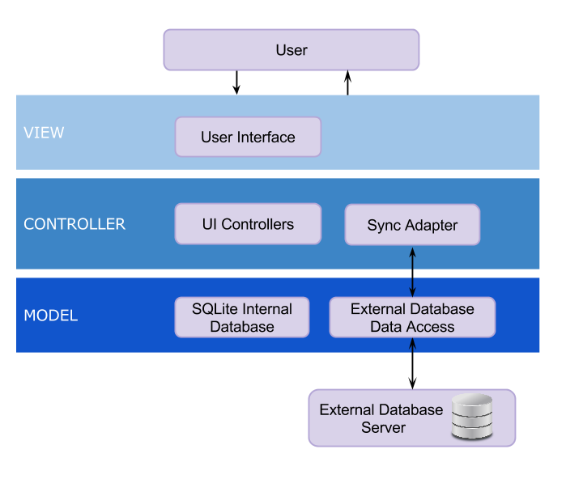

The three-tier architecture is composed of an interface layer, application layer and storage:

* **Interface layer**: the view of the system, it includes all boundary objects such as buttons, input text fields and more.
* **Application layer**: is the controller of the system, it includes all the Android activities.
* **Storage**: is the model of the system that realizes the storage and retrieval of persistent objects from either our SQLite database or the external MySQL Database.

## System and Subsystem Decomposition

Listed below is a brief description of the functionality provided by each subsystem.

**Activity:** Symbolizes a single user interface class. It is frequently packaged together to form the UI components of the application. That is why, the controller has ZoneActivity, ZoneDescription Activity and Login Activity.

**Model:** Permits the access to the database like SQLite and My SQL Database. In brief, the logical sense is to tie the user interface components with the data store components.

**View:** The objective of this pattern is to separate the components of the user interface.  The view is defined by the XML file.

**Login:** This will welcome the users when the application started.

**Zone Activity:** This will display the zones of the user and at the same time wait for an action from the user.

**Zone description:** This will display the description of the zone selected by the user which pertains to him or her and specify the description for occupancy, light, plugload and temperature for the zone selected.

**Report:** This will display the information that the user can have access to and allow to manipulate the data to produce statistic reports. The information can be shown as a statistic or graph in order to display it for the user’s convenience.

**Report of Limited Zones:** The occupant will have a limited report of his/her zone.

**SQLite:** This is an internal Database of the device used to store data for the user that is currently logged in to the application on the mobile device.

**My SQL Database:** This is the external Database.

The following Subsystem Decomposition diagram illustrates the major subsystems that make up the SSOBEC application along with the major components that make up the subsystems.

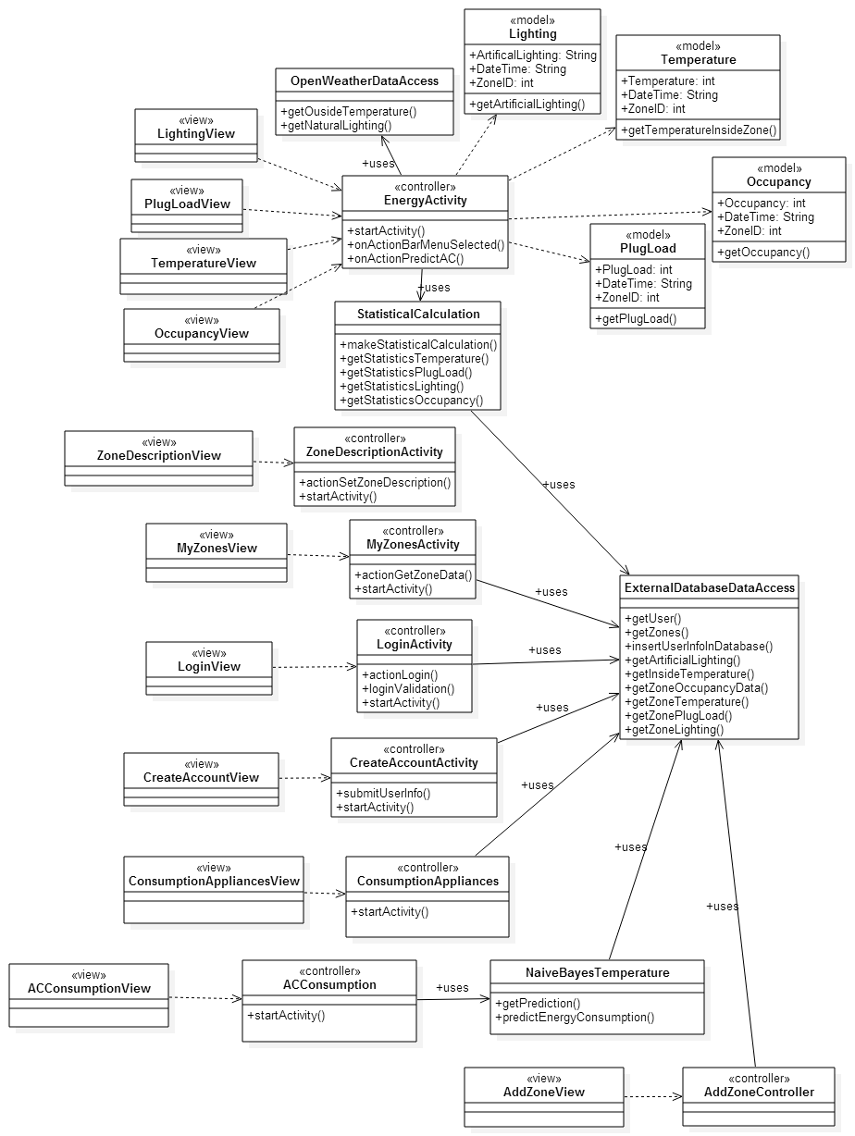

Figure 1 - Subsystem Decomposition

## Deployment Diagram

The following diagram illustrates which subsystems will reside on each hardware component and how the different pieces are connected.

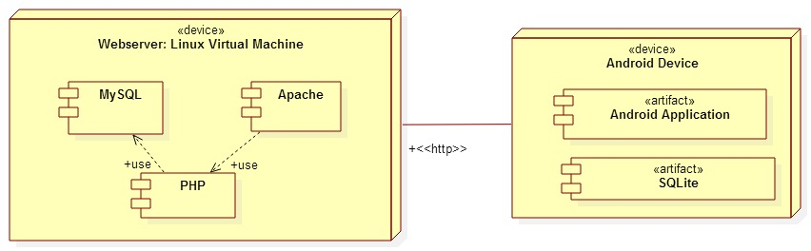

Figure 1 - Deployment Diagram

## Design Patterns

The Smart System for Occupancy and Building Energy Control was implemented using the design pattern of Model View Controller (MVC). This structural pattern was selected because it allowed the programmers versatility to code and it provides a useful organizational pattern for the application to be developed further in the future.

The Model of the system consisted of the user data and the user’s zone data. The Activities of the system served as the Controllers and depending on the type of user logged in, the activities can load the view for the facility manager user or the view for general user of the application with the functionalities available to each user type. The Views of the system consisted of the different layouts implemented for different user types. We also used adapters to be able to display data as needed in the different layouts.

The Model View Controller design allowed us to reuse layouts while maintaining the structure of the application organized as new features were implemented. It also helped us in reducing dependencies between functionalities and in maintaining version control without conflicts between features developed during the same time period.

# 

# **System Validation**

This section describes the testing performed during the implementation of the Smart System for Occupancy and Building Energy Control. Testing was done using Unit Testing (Espresso for automating UI testing), Integration Testing and System Testing. The objective of our System Tests was to make sure that the system was behaving appropriately, as defined by the requirements provided by our product owners. The test cases used in the previous version are found at the end of this section under Version 1 Test Cases.

Version 2 Test Cases:

|  |  |
| --- | --- |
| Test Case ID: | SSOBEC_Test_Login_FacilityManager_SUNNY_01 |
| Purpose: | To validate that a facility manager can login to the application. |
| Preconditions: | The app is running and the mobile device has internet connection. |
| Inputs | The facility manager user enters the username “irvsteve@gmail.com” and the password “abc123”. |
| Expected Output | The user is shown the main activity screen for a facility manager, which has the “Create Zone” functionality. |

|  |  |
| --- | --- |
| Test Case ID: | SSOBEC_Test_Login_GeneralUser_SUNNY_01 |
| Purpose: | To validate that a general user can login to the application. |
| Preconditions: | The app is running and the mobile device has internet connection. |
| Inputs | The user enters the username “ana@hotmail.com” and the password “nana”. |
| Expected Output | The user is shown the main activity screen with his\her zones, which has the “My Reports”, “My Rewards” and “Save Energy” functionalities. |

|  |  |
| --- | --- |
| Test Case ID: | SSOBEC_Test_Unfollow_Zone_SUNNY_01 |
| Purpose: | To validate that a user can unfollow a zone. |
| Preconditions: | The app is running and the mobile device has internet connection.  The user has logged in with username “ana@hotmail.com” and the password “nana”. The zone Math Office has been previously added by the user. |
| Inputs | The user swipes sideways towards the left on zone Math Office and selects the trash bin icon that appears. |
| Expected Output | The user is shown the main activity screen with his\her zones and the zone Math Office is removed from the user’s zones shown. |

|  |  |
| --- | --- |
| Test Case ID: | SSOBEC_Test_View_Account_Reward_Points_SUNNY_01 |
| Purpose: | To validate that a user can view his/her account reward points. |
| Preconditions: | The app is running and the mobile device has internet connection.  The user has logged in with username “ana@hotmail.com” and the password “nana”. |
| Inputs | The user selects the “My Rewards” button on the main screen. |
| Expected Output | The user is shown the My Rewards activity screen with Ana’s total reward points and the itemized list of the rewards earned. |

|  |  |
| --- | --- |
| Test Case ID: | SSOBEC_Test_Create_Zone_SUNNY_01 |
| Purpose: | To validate that a facility manager can create a zone. |
| Preconditions: | The app is running and the mobile device has internet connection.  The user is a valid facility manager user and has logged in. |
| Inputs | The facility manager user clicks on the “Create Zone” button.  On the CreateZoneActivity, the user enters the Zone Name as “Testing Zone”, Zone Location as “ECS” and Windows as “1”.  The user clicks on the Create Zone button in the CreateZone Activity. |
| Expected Output | The user is shown the main activity screen with his\her zones. |

|  |  |
| --- | --- |
| Test Case ID: | SSOBEC_Test_Create_Zone_RAINY_01 |
| Purpose: | To validate that a facility manager cannot create a zone with blank Zone Name. |
| Preconditions: | The app is running and the mobile device has internet connection.  The user is a valid facility manager user and has logged in. |
| Inputs | The facility manager user clicks on the “Create Zone” button.  On the CreateZoneActivity, the user leaves the Zone Name blank, and enters Zone Location as “ECS” and Windows as “1”.  The user clicks on the Create Zone button in the CreateZone Activity. |
| Expected Output | The user is shown a warning message saying "Zone Name cannot be empty!". |

|  |  |
| --- | --- |
| Test Case ID: | SSOBEC_Test_Create_Zone_RAINY_02 |
| Purpose: | To validate that a facility manager cannot create a zone using apostrophes in the Zone Name. |
| Preconditions: | The app is running and the mobile device has internet connection.  The user is a valid facility manager user and has logged in. |
| Inputs | The facility manager user clicks on the “Create Zone” button.  On the CreateZoneActivity, the user enters the Zone Name as “TEST’2”, and enters Zone Location as “ECS” and Windows as “1”.  The user clicks on the Create Zone button in the CreateZone Activity. |
| Expected Output | The user is shown a warning message saying "Please do not use quotations or apostrophes.". |

|  |  |
| --- | --- |
| Test Case ID: | SSOBEC_Test_Create_Zone_RAINY_03 |
| Purpose: | To validate that a facility manager cannot create a zone using quotations in the Zone Name. |
| Preconditions: | The app is running and the mobile device has internet connection.  The user is a valid facility manager user and has logged in. |
| Inputs | The facility manager user clicks on the “Create Zone” button.  On the CreateZoneActivity, the user enters the Zone Name as: TEST’3  Enter Zone Location as “ECS” and Windows as “1”.  The user clicks on the Create Zone button in the CreateZone Activity. |
| Expected Output | The user is shown a warning message saying "Please do not use quotations or apostrophes.". |

|  |  |
| --- | --- |
| Test Case ID: | SSOBEC_Test_Create_Zone_RAINY_04 |
| Purpose: | To validate that a facility manager cannot create a zone using apostrophes in the Zone Location. |
| Preconditions: | The app is running and the mobile device has internet connection.  The user is a valid facility manager user and has logged in. |
| Inputs | The facility manager user clicks on the “Create Zone” button.  On the CreateZoneActivity, the user enters the Zone Name as “TEST4”, and enters Zone Location as “ECS’s” and Windows as “1”.  The user clicks on the Create Zone button in the CreateZone Activity. |
| Expected Output | The user is shown a warning message saying "Please do not use quotations or apostrophes.". |

|  |  |
| --- | --- |
| Test Case ID: | SSOBEC_Test_Create_Zone_RAINY_05 |
| Purpose: | To validate that a facility manager cannot create a zone using quotations in the Zone Location. |
| Preconditions: | The app is running and the mobile device has internet connection.  The user is a valid facility manager user and has logged in. |
| Inputs | The facility manager user clicks on the “Create Zone” button.  On the CreateZoneActivity, the user enters the Zone Name as “TEST5”, and enters Zone Location as: ECS”s and enters Windows as “1”.  The user clicks on the Create Zone button in the CreateZone Activity. |
| Expected Output | The user is shown a warning message saying "Please do not use quotations or apostrophes.". |
| Test Case ID: | SSOBEC_Test_Create_Zone_RAINY_06 |
| Purpose: | To validate that a facility manager cannot create a zone using apostrophes in the Zone Name. |
| Preconditions: | The app is running and the mobile device has internet connection.  The user is a valid facility manager user and has logged in. |
| Inputs | The facility manager user clicks on the “Create Zone” button.  On the CreateZoneActivity, the user enters the Zone Name as “TEST6”, and enters Zone Location as “ECS” and Windows as: 1’  The user clicks on the Create Zone button in the CreateZone Activity. |
| Expected Output | The user is shown a warning message saying "Please do not use quotations or apostrophes.". |

|  |  |
| --- | --- |
| Test Case ID: | SSOBEC_Test_Create_Zone_RAINY_07 |
| Purpose: | To validate that a facility manager cannot create a zone using quotations in the zone Windows. |
| Preconditions: | The app is running and the mobile device has internet connection.  The user is a valid facility manager user and has logged in. |
| Inputs | The facility manager user clicks on the “Create Zone” button.  On the CreateZoneActivity, the user enters the Zone Name as “TEST7”  Enter Zone Location as “ECS” and Windows as: 1”  The user clicks on the Create Zone button in the CreateZone Activity. |
| Expected Output | The user is shown a warning message saying "Please do not use quotations or apostrophes.". |

|  |  |
| --- | --- |
| Test Case ID: | SSOBEC_Test_View_Wasteful_Regions_User_SUNNY_01 |
| Purpose: | To validate that a user can view wasteful regions in the building. |
| Preconditions: | The app is running and the mobile device has internet connection.  The user has logged in with username “ana@hotmail.com” and the password “nana”. |
| Inputs | The user selects the “Save Energy” button on the main screen. |
| Expected Output | The user is shown the View Wasteful Regions activity screen with a list of the wasteful regions. |

|  |  |
| --- | --- |
| Test Case ID: | SSOBEC_Test_View_Wasteful_Regions_FacilityManager_SUNNY_01 |
| Purpose: | To validate that a facility manager can view wasteful regions in the building. |
| Preconditions: | The app is running and the mobile device has internet connection.  A facility manager has logged in with username “dlean001@fiu.edu” and the password “dia”. |
| Inputs | The user selects the “Save Energy” button on the main screen. |
| Expected Output | The user is shown the View Wasteful Regions activity screen with a list of the wasteful regions. |

|  |  |
| --- | --- |
| Test Case ID: | SSOBEC_Test_Edit_Zone_Windows_SUNNY_01 |
| Purpose: | To validate that a user can edit a zone’s number of windows. |
| Preconditions: | The app is running and the mobile device has internet connection.  A facility manager has logged in with username “ana@hotmail.com” and the password “nana”. |
| Inputs | The user selects the House icon on the Action Bar in the main screen. The user then selects the Pencil icon next to “Ana Office 1”. The user clicks on the number of windows edit field and selects number 1 from the scrollable list and clicks Set button. The user then clicks the Save button. A message of SuccesfullUpdate should pop up. The user clicks the back button on the activity.  The user then selects the Pencil icon next to “Ana Office 1” from the list of zones. |
| Expected Output | The user is shown the name “Ana Office 1”, the location “ECS 123” and the windows as “1”. |

|  |  |
| --- | --- |
| Test Case ID: | SSOBEC_Test_Edit_Zone_Location_SUNNY_01 |
| Purpose: | To validate that a user can edit a zone location in the building. |
| Preconditions: | The app is running and the mobile device has internet connection.  A facility manager has logged in with username “ana@hotmail.com” and the password “nana”. |
| Inputs | The user selects the House icon on the Action Bar in the main screen. The user then selects the Pencil icon next to “Ana Office 1”. The user clicks on the location edit field and enters “ECS 123” and clicks the Save button. A message of SuccesfullUpdate should pop up. The user clicks the back button on the activity.  The user then selects the Pencil icon next to “Ana Office 1” from the list of zones. |
| Expected Output | The user is shown the name “Ana Office 1”, the location “ECS 123” and the windows as “1”. |

|  |  |
| --- | --- |
| Test Case ID: | SSOBEC_Test_Edit_Zone_Name_SUNNY_01 |
| Purpose: | To validate that a user can edit a zone name in the building. |
| Preconditions: | The app is running and the mobile device has internet connection.  A facility manager has logged in with username “ana@hotmail.com” and the password “nana”. |
| Inputs | The user selects the House icon on the Action Bar in the main screen. The user then selects the Pencil icon next to “Ana Office 1”. The user clicks on the name edit field and enters “Ana Office 2” and clicks the Save button. A message of SuccesfullUpdate should pop up. The user clicks the back button on the activity.  The user then selects the Pencil icon next to “Ana Office 2” from the list of zones. |
| Expected Output | The user is shown the name “Ana Office 2”, the location “ECS 123” and the windows as “1”. |

|  |  |
| --- | --- |
| Test Case ID: | SSOBEC_Test_Add_Appliance_SUNNY_01 |
| Purpose: | To validate that a user can add an appliance to a zone in the building. |
| Preconditions: | The app is running and the mobile device has internet connection.  A facility manager has logged in with username “ana@hotmail.com” and the password “nana”. |
| Inputs | The user selects the zone “Ana Office 1”. The user clicks on Add Appliance icon in the Action Bar. A list of appliances for the zone is displayed. The user clicks the Add button and a dialog box appears.  The user then enters Appliance name as “A TV 2” and clicks the Set button. |
| Expected Output | The user is shown again a list of appliances and “A TV 2” is shown in the list. |

|  |  |
| --- | --- |
| Test Case ID: | SSOBEC_Test_Add_User_to_Zone_FacilityManager_SUNNY_01 |
| Purpose: | To validate that a facility manager can add a user to a zone in the building. |
| Preconditions: | The app is running and the mobile device has internet connection.  A facility manager has logged in with username “dlean001@fiu.edu” and the password “dia”. |
| Inputs | The user selects the Users icon on the Action Bar in the main screen. A list of all zones is displayed and the user selects the Add User icon next to “Lunch Room”. The user enters the valid user email address “frank@gmail.com”. The user clicks Add User button on the activity. |
| Expected Output | A message pops up saying Succesful. |

|  |  |
| --- | --- |
| Test Case ID: | SSOBEC_Test_Add_User_to_Zone_FacilityManager_RAINY_01 |
| Purpose: | To validate that a facility manager cannot add the same user twice to a zone that the user has already added. |
| Preconditions: | The app is running and the mobile device has internet connection.  A facility manager has logged in with username “dlean001@fiu.edu” and the password “dia”. The user Frank has already added the zone Lunch Room to his list of zones. |
| Inputs | The user selects the Users icon on the Action Bar in the main screen. A list of all zones is displayed and the user selects the Add User icon next to “Lunch Room”. The user enters the valid user email address “frank@gmail.com”. The user clicks Add User button on the activity. |
| Expected Output | An error message pops up saying Mysql Error 2: Duplicate Entry… |

|  |  |
| --- | --- |
| Test Case ID: | SSOBEC_Test_Remove_User_from_Zone_FacilityManager_SUNNY_01 |
| Purpose: | To validate that a facility manager can remove a user from a zone in the building. |
| Preconditions: | The app is running and the mobile device has internet connection.  A facility manager has logged in with username “dlean001@fiu.edu” and the password “dia”. The user Frank has already added the zone Lunch Room to his list of zones. |
| Inputs | The user selects the Users icon on the Action Bar in the main screen. A list of all zones is displayed and the user selects the Remove User icon for “Lunch Room” zone. The user enters the valid user email address “frank@gmail.com”. The user clicks Remove User button on the activity. |
| Expected Output | A message pops up saying Succesful. |

|  |  |
| --- | --- |
| Test Case ID: | SSOBEC_Test_Remove_User_from_Zone_FacilityManager_RAINY_01 |
| Purpose: | To validate that a facility manager cannot remove an invalid user from a zone. |
| Preconditions: | The app is running and the mobile device has internet connection.  A facility manager has logged in with username “dlean001@fiu.edu” and the password “dia”. |
| Inputs | The user selects the Users icon on the Action Bar in the main screen. A list of all zones is displayed and the user selects the Remove User icon next to “Lunch Room”. The user enters an invalid user email address “hhhhh”. The user clicks Remove User button on the activity. |
| Expected Output | The application remains in the Remove User activity and no message is shown. |

|  |  |
| --- | --- |
| Test Case ID: | SSOBEC_Test_TunOffLight_Wasteful_Region_SUNNY_01 |
| Purpose: | To validate that a user can turn off light in a wasteful region in the building and earn points. |
| Preconditions: | The app is running and the mobile device has internet connection.  The user has logged in with username “ana@hotmail.com” and the password “nana”. The Math Office has the light ON with no occupants. |
| Inputs | The user selects the “Save Energy” button on the main screen. The user sees the list of wasteful regions and selects the Lightbulb icon next to the Math Office which has the Light ON and No Occupants. The user clicks on “Turned Off Light” button. |
| Expected Output | The user gets a message saying “Congrats on Saving Energy!” and is redirected to the main screen. |

|  |  |
| --- | --- |
| Test Case ID: | SSOBEC_Test_TunOffAppliance_Wasteful_Region_SUNNY_01 |
| Purpose: | To validate that a user can turn off appliance in a wasteful region in the building and earn points. |
| Preconditions: | The app is running and the mobile device has internet connection.  The user has logged in with username “ana@hotmail.com” and the password “nana”. |
| Inputs | The user selects the “Save Energy” button on the main screen. The user sees the list of wasteful regions and selects the Plugload icon next to the Book Store. The user clicks on “Turned Off Appliance” button. |
| Expected Output | The user gets a message saying “Congrats on Saving Energy!” and is redirected to the main screen. |

|  |  |
| --- | --- |
| Test Case ID: | SSOBEC_Test_Send_Notification_SUNNY_01 |
| Purpose: | To validate that a user can send email notifications to the users of a wasteful region in the building. |
| Preconditions: | The app is running and the mobile device has internet connection.  The user has logged in with username “ana@hotmail.com” and the password “nana”. The Math Office has the light ON with no occupants. |
| Inputs | The user selects the “Save Energy” button on the main screen. The user sees the list of wasteful regions and selects the Envelope icon next to the Math Office which has the Light ON and No Occupants. The user sees the list of emails of users of the Math office zone. The user clicks on “Send Notifications” button. |
| Expected Output | The user gets a message saying “Notifications Sent …” and is redirected to the main screen. |

|  |  |
| --- | --- |
| Test Case ID: | SSOBEC_Test_Earn_Points_after_Sending_Notification_SUNNY_01 |
| Purpose: | To validate that a user can send email notifications to the users of a wasteful region in the building and earn points. |
| Preconditions: | The app is running and the mobile device has internet connection.  The user has logged in with username “frank@gmail.com” and the password “frank2”. The Math Office has the light ON with no occupants. |
| Inputs | The user selects the “Save Energy” button on the main screen. The user sees the list of wasteful regions and selects the Envelope icon next to the Math Office which has the Light ON and No Occupants. The user sees the list of emails of users of the Math office zone. The user clicks on “Send Notifications” button. The user then gets a message saying “Notifications Sent …” and is redirected to the main screen.  The user clicks on “My Rewards” button on the main screen. |
| Expected Output | The user sees his total reward points and at the bottom of the itemized list of his rewards the user sees “Send Notifications” with “+3” points and the timestamp of when the notification was sent. |

|  |  |
| --- | --- |
| Test Case ID: | SSOBEC_Test_Generate_User_Report_FacilityManager_SUNNY_01 |
| Purpose: | To validate that a facility manager can view the User statistics report. |
| Preconditions: | The app is running and the mobile device has internet connection.  The facility manager user is logged in with the username “irvsteve@gmail.com” and the password “abc123”. |
| Inputs | The user clicks on the “Reports” button and selects the tab “Users Comparison”. |
| Expected Output | The user is shown a graph view of all the Energy Savings Reward by User shown from highest ranking to lowest. |

|  |  |
| --- | --- |
| Test Case ID: | SSOBEC_Test_Generate_Zone_Report_FacilityManager_SUNNY_01 |
| Purpose: | To validate that a facility manager can view the zone statistics report. |
| Preconditions: | The app is running and the mobile device has internet connection.  The facility manager user is logged in with the username “irvsteve@gmail.com” and the password “abc123”. |
| Inputs | The user clicks on the “Reports” button and selects the tab “Zones Comparison”. |
| Expected Output | The user is shown a list view of the High, Median, and Low zones by energy consumption and a graph view of the energy consumption by plugload of all the zones in the building shown from highest to lowest. The user also sees the average energy consumption for all the zones of the building. |

|  |  |
| --- | --- |
| Test Case ID: | SSOBEC_Test_View_Suggestions_Report_FacilityManager_SUNNY_01 |
| Purpose: | To validate that a facility manager can view the suggestions report. |
| Preconditions: | The app is running and the mobile device has internet connection.  The facility manager user is logged in with the username “irvsteve@gmail.com” and the password “abc123”. |
| Inputs | The user clicks on the “Reports” button and selects the tab “Suggestions”. |
| Expected Output | The user is shown a comparison of his\her average energy consumption with the average energy consumption of the building. The user is shown the zones in the building that are above the average energy consumption and the Percent Consumption of these zones. |

|  |  |
| --- | --- |
| Test Case ID: | SSOBEC_Test_View_User_Rankings_GeneralUser_SUNNY_01 |
| Purpose: | To validate that a general user can view the User rankings report. |
| Preconditions: | The app is running and the mobile device has internet connection.  The user has logged in with username “frank@gmail.com” and the password “frank2”. |
| Inputs | The user clicks on the “My Reports” button and selects the tab “My Ranking”. |
| Expected Output | The user is shown his rank and a graph view of all users reward points shown from highest ranking to lowest. |

|  |  |
| --- | --- |
| Test Case ID: | SSOBEC_Test_Generate_Zone_Report_FacilityManager_SUNNY_01 |
| Purpose: | To validate that a general user can view his\her zone statistics report. |
| Preconditions: | The app is running and the mobile device has internet connection.  The user has logged in with username “frank@gmail.com” and the password “frank2”. |
| Inputs | The user clicks on the “My Reports” button and selects the tab “My Zones”. |
| Expected Output | The user is shown a list view of the High, Median, and Low zones by energy consumption and a graph view of the energy consumption by plugload of all his\her zones in the building shown from highest to lowest. The user also sees the average energy consumption for all the zones of the building and for his\her zones. |

|  |  |
| --- | --- |
| Test Case ID: | SSOBEC_Test_View_Suggestions_Report_GeneralUser_SUNNY_01 |
| Purpose: | To validate that a general user can view his\her Suggestions report. |
| Preconditions: | The app is running and the mobile device has internet connection.  The user has logged in with username “frank@gmail.com” and the password “frank2”. |
| Inputs | The user clicks on the “My Reports” button and selects the tab “Suggestions”. |
| Expected Output | The user is shown a comparison of his\her average energy consumption with the average energy consumption of the building. The user is shown his\her zones in the building that are above the average energy consumption and the Percent Consumption of these zones. |

Version 1 Test Cases:

|  |  |
| --- | --- |
| Test Case ID: | SSOBEC_Test_View_Login_SUNNY_01 |
| Purpose: | To validate the user login into the system. |
| Preconditions: | The app is running and the mobile device has internet connection.  The user is a valid user. |
| Inputs | User Name: Frank@ gmail.com  Password: Frank2  Click Login button |
| Expected Output | The user can see my zone because he/she made a successful login. |

|  |  |
| --- | --- |
| Test Case ID: | SSOBEC_Test_View_Login_RAINY_01 |
| Purpose: | To validate when the user enter the wrong password, he or she cannot login into the system. |
| Preconditions: | The app is running and the mobile device has internet connection.  The user is a valid user. |
| Inputs | User Name: Frank@ gmail.com  Password: Frank222  Click Login button |
| Expected Output | The user cannot make a login “Wrong email or password”. |

|  |  |
| --- | --- |
| Test Case ID: | SSOBEC_Test_View_Logout_SUNNY_01 |
| Purpose: | To validate that the user can log out from an account that is currently logged in. |
| Preconditions: | The app is running and the mobile device has internet connection.  The user is a valid user.  The user is in one of the activity of the application. |
| Inputs | None |
| Expected Output | The user can see the Login View. |

|  |  |
| --- | --- |
| Test Case ID: | SSOBEC_Test_Create_Account_SUNNY_01 |
| Purpose: | To validate that the user can create a new account with an email that does not exist in the database |
| Preconditions: | The app is running and the mobile device has internet connection.  The user is in the Login Activity  The user made a click in the button Create Account |
| Inputs | Enter First Name  Enter Last Name  Enter Email  Enter Password  Repeat Password |
| Expected Output | The user can see the Login View and made a successful login. |

|  |  |
| --- | --- |
| Test Case ID: | SSOBEC_Test_Create_Account_RAINY_01 |
| Purpose: | To validate that the user inputs the same password and repeat password |
| Preconditions: | The app is running and the mobile device has internet connection.  The user is in the Create Account  The user made a click in the Submit button |
| Inputs | Enter First Name  Enter Last Name  Enter Email  Enter Password  Enter Different Repeat Password |
| Expected Output | The user gets a warning message that password and repeat password are both different. |

|  |  |
| --- | --- |
| Test Case ID: | SSOBEC_Test_View_Temperature_Inside_Building_SUNNY_01 |
| Purpose: | To validate that the system correctly displays the information regarding temperature inside the building. |
| Preconditions: | The user’s android device is connected to the database |
| Inputs | User selects a zone in My Zones view.  User clicks the Temperature button to see the temperature inside the building information of the zone. |
| Expected Output | The system retrieves the information from the database and displays the temperature inside the building information. |

|  |  |
| --- | --- |
| Test Case ID: | SSOBEC_Test_View_Temperature_Outside_Building_SUNNY_01 |
| Purpose: | To validate that the system correctly displays the information regarding temperature outside the building. |
| Preconditions: | The user’s android device is connected to the database |
| Inputs | User selects a zone in My Zones view.  User clicks the Temperature button to see the temperature outside the building information of the zone. |
| Expected Output | The system retrieves the information from the database and displays the temperature outside the building information. |

|  |  |
| --- | --- |
| Test Case ID: | SSOBEC_Test_View_Zone_SUNNY_01 |
| Purpose: | To validate that the system correctly displays the user’s zone list if the user has added zones in the database. |
| Preconditions: | The user’s android device is connected to the database |
| Inputs | User opens the application or logs in for the first time. |
| Expected Output | The system retrieves the zone list information and displays it in a grid view for the user |

|  |  |
| --- | --- |
| Test Case ID: | SSOBEC_Test_View_Zone_RAINY_01 |
| Purpose: | To validate that the system does not display the user’s zone list if the user has not added zones in the database. |
| Preconditions: | The user’s android device is connected to the database |
| Inputs | User opens the application or logs in for the first time. |
| Expected Output | The system displays no zones in the My Zones view for the user. |

|  |  |
| --- | --- |
| Test Case ID: | SSOBEC_Test_View_Plug_Load_SUNNY_01 |
| Purpose: | To validate that the system correctly displays the information regarding plug load of a zone. |
| Preconditions: | The user’s android device is connected to the database |
| Inputs | User selects a zone in My Zones view.  User clicks the Plug Load button to see the plug load information of the zone. |
| Expected Output | The system retrieves the information from the database and displays the appliance list name and its energy usage. |

|  |  |
| --- | --- |
| Test Case ID: | SSOBEC_Test_View_Occupancy_SUNNY_01 |
| Purpose: | To validate that the system correctly displays the information regarding occupancy of a zone. |
| Preconditions: | The user’s android device is connected to the database |
| Inputs | User selects a zone in My Zones view.  User clicks the Occupancy button to see the occupancy information of the zone. |
| Expected Output | The system retrieves the information from the database and displays the occupancy behavior of a zone. |

|  |  |
| --- | --- |
| Test Case ID: | SSOBEC_Test_View_Artificial_Lighting_SUNNY_01 |
| Purpose: | To validate that the system correctly displays the information regarding artificial lighting of a zone. |
| Preconditions: | The user’s android device is connected to the database |
| Inputs | User selects a zone in My Zones view.  User clicks the Lighting button to see the artificial lighting information of the zone. |
| Expected Output | The system retrieves the information from the database and displays the artificial lighting performance of a zone. |

|  |  |
| --- | --- |
| Test Case ID: | SSOBEC_Test_View_Statistic-Information_for_Lighting_SUNNY_01 |
| Purpose: | To validate that the system correctly displays the pie chart for lighting energy usage inside a zone. |
| Preconditions: | The user’s android device is connected to the database |
| Inputs | User selects a zone in My Zones view.  User clicks the Lighting button to see the lighting information of the zone. |
| Expected Output | The system retrieves the information from the database and displays a visualization |

|  |  |
| --- | --- |
| Test Case ID: | SSOBEC_Test_View_Statistic_Information_for_Lighting_RAINY_01 |
| Purpose: | To validate that the system does not displays the pie chart for lighting energy usage inside a zone if the phone is not connected to wifi |
| Preconditions: | The user’s android device is connected to the database.  The user’s android device is not connected to Wifi. |
| Inputs | User selects a zone in My Zones view.  User clicks the Lighting button to see the lighting information of the zone. |
| Expected Output | The system displays a message that “Unfortunately, SSOBEC hast stopped. |

|  |  |
| --- | --- |
| Test Case ID: | SSOBEC_Test_View_Statistic_Information_for_Occupancy_SUNNY_01 |
| Purpose: | To validate that the system correctly displays the graph view for occupancy behavior inside a zone. |
| Preconditions: | The user’s android device is connected to the database |
| Inputs | User selects a zone in My Zones view.  User clicks the Occupancy button to see the occupancy information of the zone. |
| Expected Output | The system retrieves the information from the database and displays a visualization |

|  |  |
| --- | --- |
| Test Case ID: | SSOBEC_Test_View_Statistic_Information_for_Temperature_SUNNY_01 |
| Purpose: | To validate that the system correctly displays the graph view for temperature behavior inside a zone. |
| Preconditions: | The user’s android device is connected to the database |
| Inputs | User selects a zone in My Zones view.  User clicks the Temperature button to see the temperature information of the zone. |
| Expected Output | The system retrieves the information from the database and displays a visualization |

|  |  |
| --- | --- |
| Test Case ID: | SSOBEC_Test_View_Statistic_Information_for_PlugLoad_SUNNY_01 |
| Purpose: | To validate that the system correctly displays the graph view for plug load energy performance inside a zone. |
| Preconditions: | The user’s android device is connected to the database |
| Inputs | User selects a zone in My Zones view.  User clicks the Plug Load button to see the plug load information of the zone. |
| Expected Output | The system retrieves the information from the database and displays a visualization |

|  |  |
| --- | --- |
| Test Case ID: | SSOBEC_Test_Predict_A_Zone_More_Likely_To_Waste_Energy_SUNNY_01 |
| Purpose: | To make a prediction of AC Energy Consumption for a user |
| Preconditions: | The app is running and the mobile device has internet connection.  The user Mandy is a valid user and has logged in.  Outside temperature is 77 according to external database of Open Weather. |
| Inputs | User selects zone by clicking “Ana’s Office”  User clicks “Predict AC Consumption button”  Type “80” in the box for “Write today’s Air Conditioning Temperature Set Point”  Click “PREDICT” |
| Expected Output | The system displays predicted AC energy consumption as “Low”. |

|  |  |
| --- | --- |
| Test Case ID: | SSOBEC_Test_Predict_A_Zone_More_Likely_To_Waste_Energy_RAINY_01 |
| Purpose: | To make a prediction of AC Energy Consumption for a user |
| Preconditions: | The app is running and the mobile device has internet connection.  The user Mandy is a valid user and has logged in.  Outside temperature is 77 according to external database of Open Weather. |
| Inputs | User selects zone by clicking “Ana’s Office”  User clicks “Predict AC Consumption button”  The user does not type any value in the box  Click “PREDICT” |
| Expected Output | The system displays “Unfortunately, SSOBEC has stopped”. And give the option to click “OK” the system returns the user to the Zone Description View where he/she can make a new selection. |

|  |  |
| --- | --- |
| Test Case ID: | SSOBEC_Test_Predict_How_Energy_Saving_Literacy_Save_Energy_SUNNY_01 |
| Purpose: | To make a prediction of Appliance Consumption for a user |
| Preconditions: | The app is running and the mobile device has internet connection.  The user Mandy is a valid user and has logged in.  The view displays a list of the appliances currently in Mandy’s office |
| Inputs | User selects zone by clicking “Ana’s Office”  User clicks “Predict Consumption of Appliances button”  User selects the desired appliance  User inputs the amount of appliances  User inputs the hours of user for the appliances  User inputs the day of use for the appliances  User clicks monthly consumption |
| Expected Output | The system displays the prediction of monthly consumption according to the information given by the user. |

|  |  |
| --- | --- |
| Test Case ID: | SSOBEC_Test_Predict_How_Energy_Saving_Literacy_Save_Energy_SUNNY_02 |
| Purpose: | To make a prediction of Appliance Consumption for a user |
| Preconditions: | The app is running and the mobile device has internet connection.  The user Mandy is a valid user and has logged in.  The view displays a list of the appliances currently in Mandy’s office |
| Inputs | User selects zone by clicking “Ana’s Office”  User clicks “Predict Consumption of Appliances button”  User selects the desired appliance  User inputs the amount of appliances  User inputs the hours of user for the appliances  User inputs the day of use for the appliancesUser clicks monthly cost |
| Expected Output | The system displays the prediction of monthly cost according to the information given by the user. |

|  |  |
| --- | --- |
| Test Case ID: | SSOBEC_Test_Predict_How_Energy_Saving_Literacy_Save_Energy_RAINY_01 |
| Purpose: | Does not make a prediction of Appliance Consumption for a user if he/she forgets to select the appliance in the “Electric Appliances” list. |
| Preconditions: | The app is running and the mobile device has internet connection.  The user Mandy is a valid user and has logged in.  The view displays a list of the appliances currently in Mandy’s office |
| Inputs | User selects zone by clicking “Ana’s Office”  User clicks “Predict Consumption of Appliances button”  User does not select the desired appliance  User inputs the amount of appliances  User inputs the hours of user for the appliances  User inputs the day of use for the appliances  User clicks monthly cost |
| Expected Output | The system displays the prediction of monthly cost as $0. |

|  |  |
| --- | --- |
| Test Case ID: | SSOBEC_Test_Predict_How_Energy_Saving_Literacy_Save_Energy_RAINY_02 |
| Purpose: | Does not make a prediction of Appliance Consumption for a user if he/she forgets to select the appliance in the “Electric Appliances” list. |
| Preconditions: | The app is running and the mobile device has internet connection.  The user Mandy is a valid user and has logged in.  The view displays a list of the appliances currently in Mandy’s office |
| Inputs | User selects zone by clicking “Ana’s Office”  User clicks “Predict Consumption of Appliances button”  User does not select the desired appliance  User inputs the amount of appliances  User inputs the hours of user for the appliances  User inputs the day of use for the appliances  User clicks monthly consumption |
| Expected Output | The system displays the prediction of monthly consumption as 0 kwh. |

|  |  |
| --- | --- |
| Test Case ID: | SSOBEC_Test_Add_Zone_SUNNY_01 |
| Purpose: | To validate that the system correctly display a new zone to the user’s zone list if the user has added it. |
| Preconditions: | The user’s android device is connected to the database |
| Inputs | User clicks the Add Zone button in the upper right hand corner of the My Zones view.  User clicks the plus sign besides the zone’s name. |
| Expected Output | When the user goes back to the My Zones view, he/she will be able to see the new zone. |

|  |  |
| --- | --- |
| Test Case ID: | SSOBEC_Test_Add_Zone_RAINY_01 |
| Purpose: | To validate that the system does not let the user add a zone that he/she has already added. |
| Preconditions: | The user’s android device is connected to the database |
| Inputs | User clicks the Add Zone button in the upper right hand corner of the My Zones view.  User clicks the plus sign besides the zone’s name. |
| Expected Output | The application hides the plus sign button so that the user cannot add a zone that has already been added. |

|  |  |
| --- | --- |
| Test Case ID: | SSOBEC_Test_Compare_Room_Energy_Performance_SUNNY_01 |
| Purpose: | To validate that the system correctly displays a pie chart of the average energy performance of a building calculated from the database. |
| Preconditions: | The user’s android device is connected to the database |
| Inputs | User selects a zone.  User clicks the Lighting button |
| Expected Output | The application displays a pie chart with the average energy usage information of the building |

|  |  |
| --- | --- |
| Test Case ID: | SSOBEC_Test_View_Reward_from_people_That_Save_Energy_SUNNY_01 |
| Purpose: | To validate the case where the Reward was assigned the application is running and the mobile device has internet connection. |
| Preconditions: | The user Frank is a valid user.  The user Frank has the following zone added: Frank Office. |
| Inputs | User Name: Frank@ gmail.com  Password: Frank2 |
| Expected Output | System shows the specific Reward on the bottom half of the application page.  The system displays the reward from Frank Office. |

|  |  |
| --- | --- |
| Test Case ID: | SSOBEC_Test_View_Login_RAINY_01 |
| Purpose: | To validate when the user enter the wrong password, he or she cannot login into the system. |
| Preconditions: | The app is running and the mobile device has internet connection.  The user is a valid user. |
| Inputs | User Name: Frank@ gmail.com  Password: Frank222 |
| Expected Output | The user cannot make a login “Wrong email or password”. |

|  |  |
| --- | --- |
| Test Case ID: | SSOBEC_Test_View_Login_RAINY_01 |
| Purpose: | To validate when the user enter the wrong password, he or she cannot login into the system. |
| Preconditions: | The app is running and the mobile device has internet connection.  The user is a valid user. |
| Inputs | User Name: Frank@ gmail.com  Password: Frank222 |
| Expected Output | The user cannot make a login “Wrong email or password”. |

# **Glossary**

**Android Studio**: Is the official IDE that it is used by Android application development based on IntelliJ IDEA.

**Class Diagram**: An illustration of all the classes in the system.

**Facility Manager User**: Person that has registered in the application and has administrator access privileges within the application.

**General User**: Person that has registered in the application and has user access privileges within the application.

**Sequence Diagram**: An illustration on how processes operate with one another and the user during the execution of one specific functionality.

**SSOBEC**: Is an app that aims to help people learn to reduce consume of energy.

Use Case: List of steps describing the interaction between a user and a system to achieve one goal.

**User Story**: is used in Agile software development to create a very high-level definition of a requirement by describing the type of user, what they want and why. (1)

**Task**: A piece of job that require to be done within a certain time.

# 

# **Appendix**

## Appendix A - UML Diagrams

### Static UML Diagrams

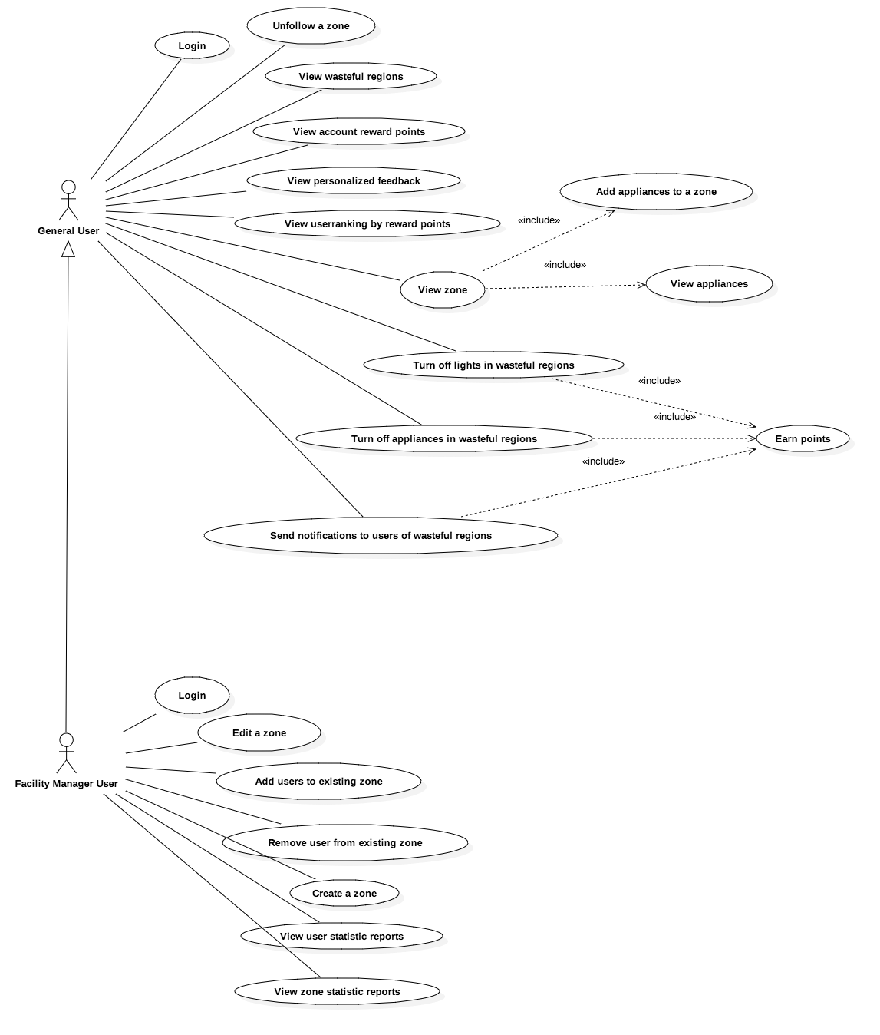

Figure 1 – Use Case Diagram

…

### Dynamic UML Diagrams

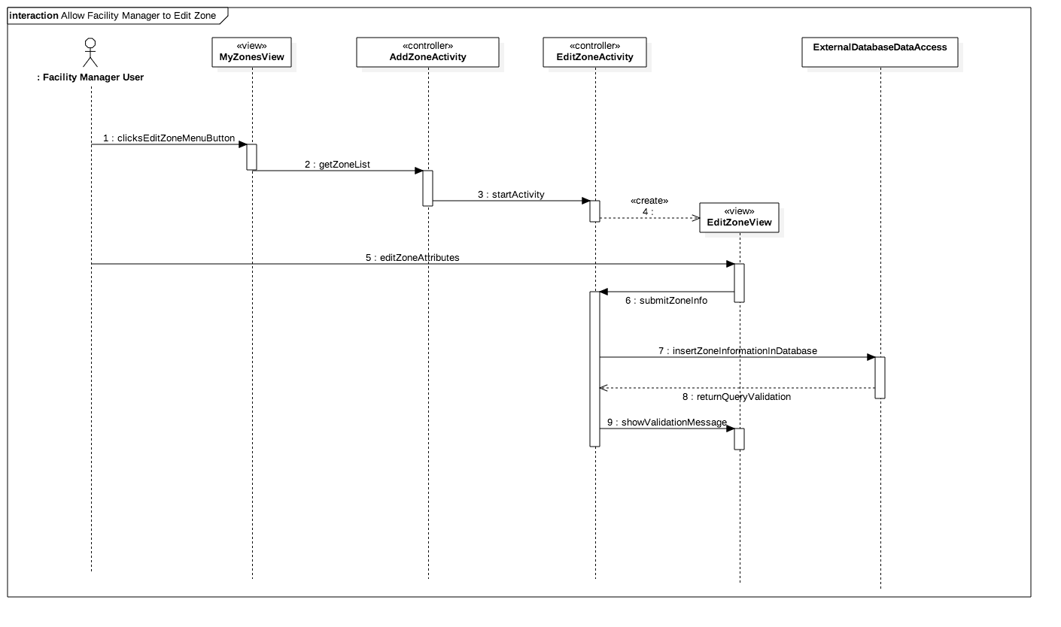

Figure 2 - Allow Facility Manager to Edit Zone

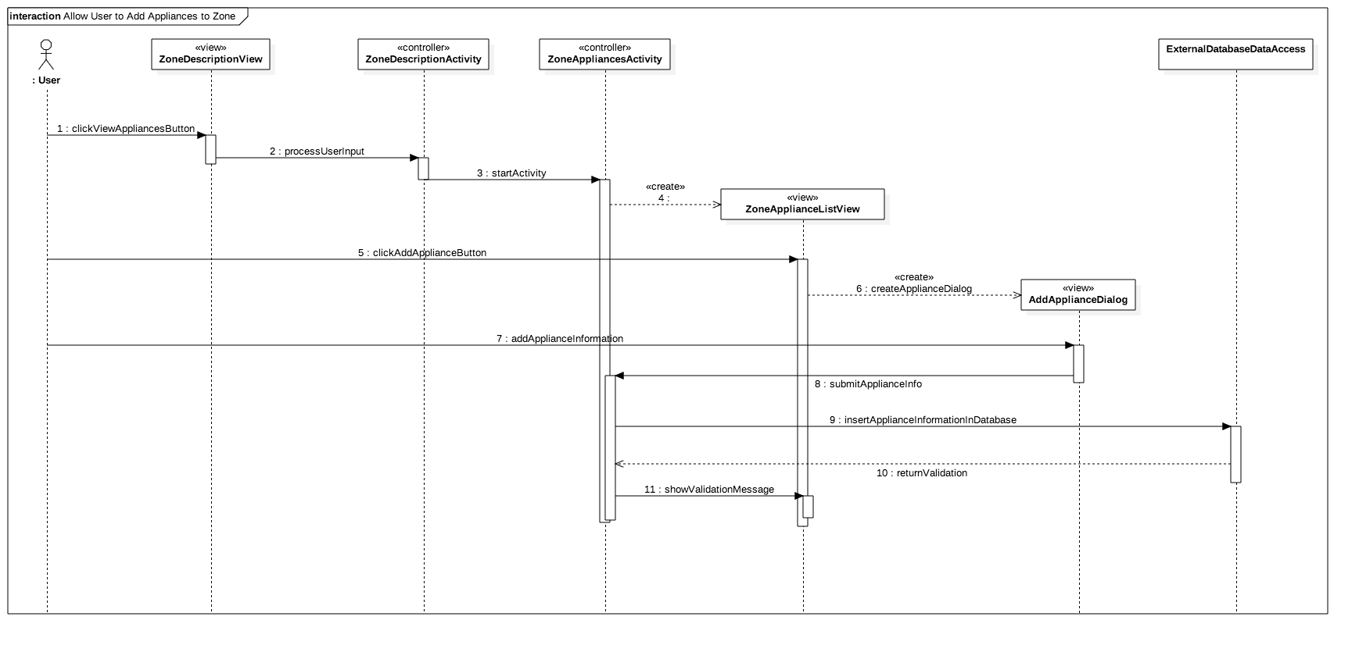

Figure 3 - Allow User to Add Appliances to Zone

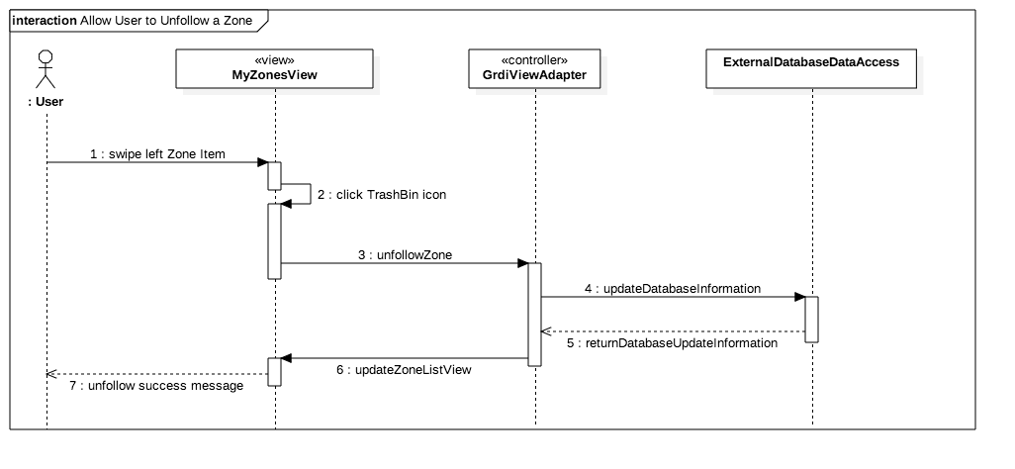

Figure 4 - Allow User to Unfollow a Zone

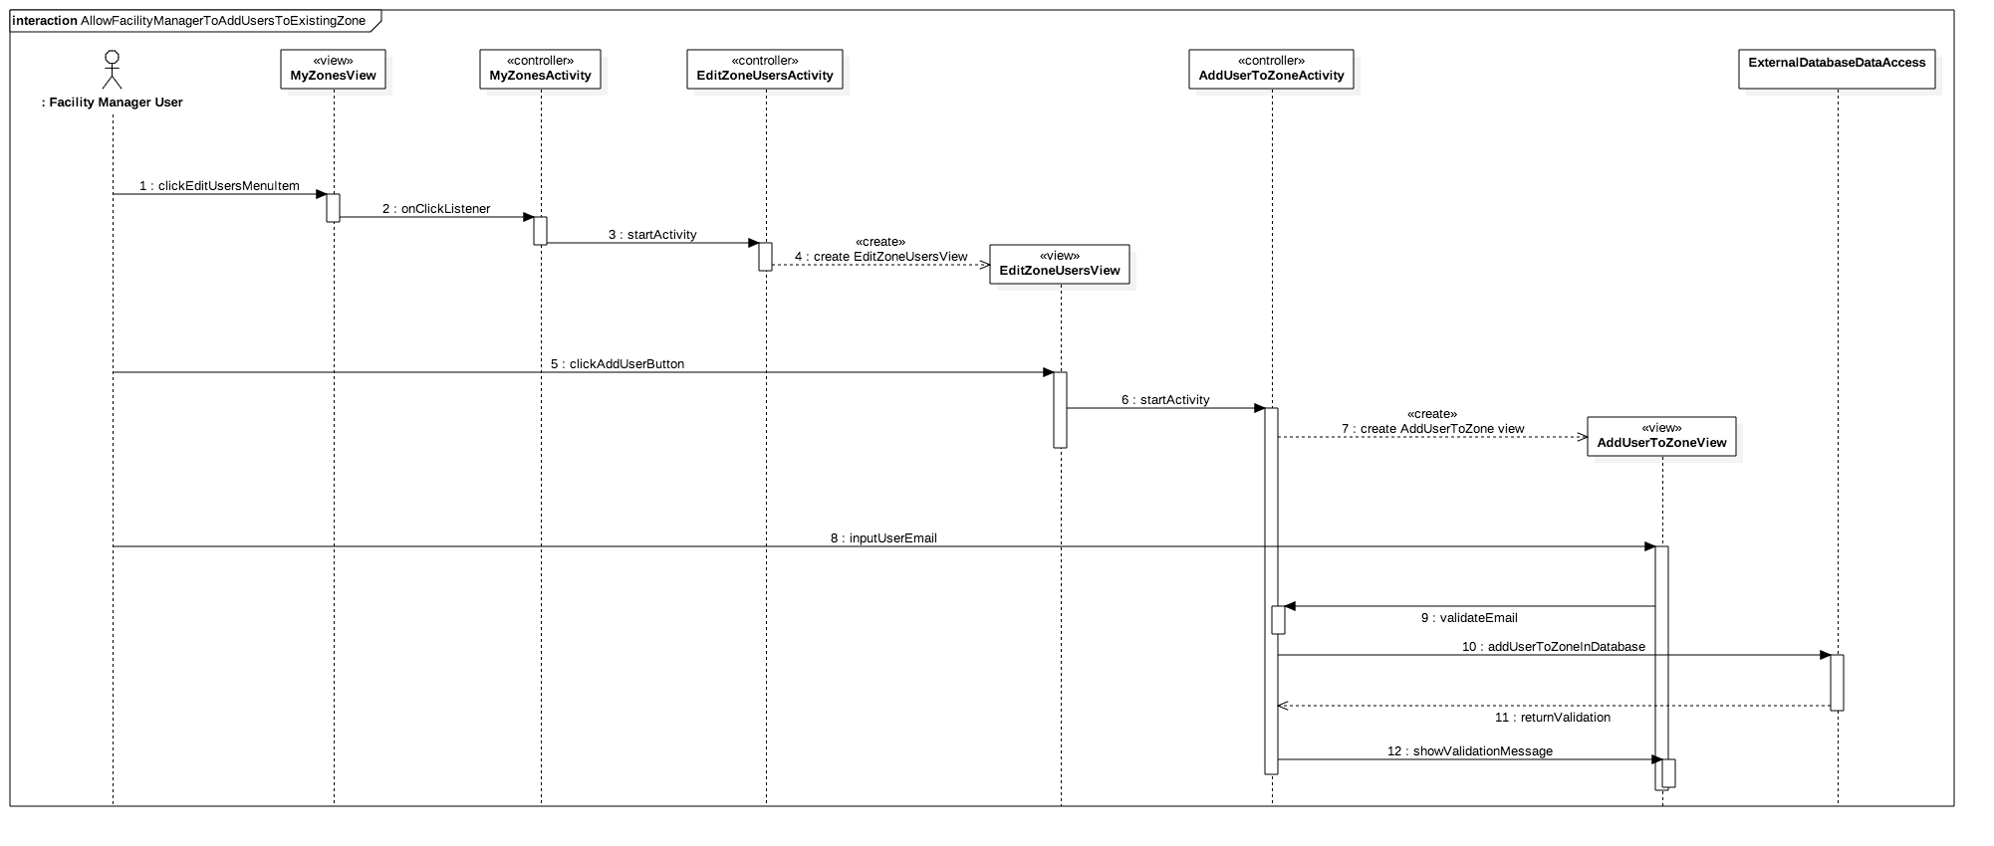

Figure 5 - Allow Facility Manager To Add Users To Existing Zone

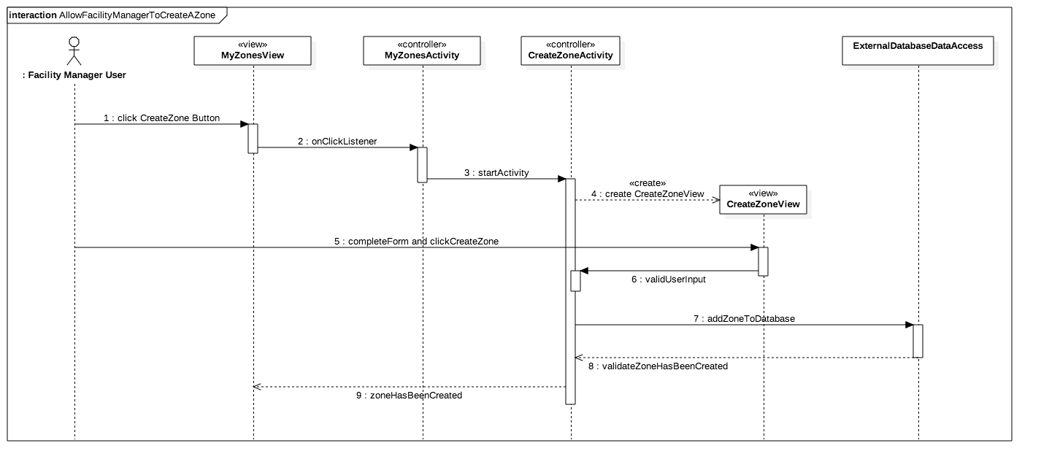

Figure 6 - Allow Facility Manager To Create A Zone

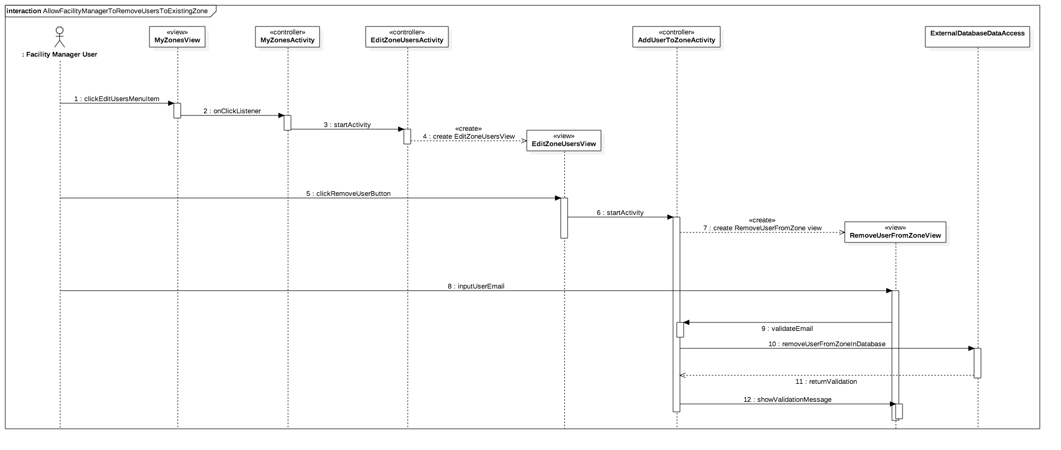

Figure 7 - Allow Facility Manager To Remove Users To Existing Zone

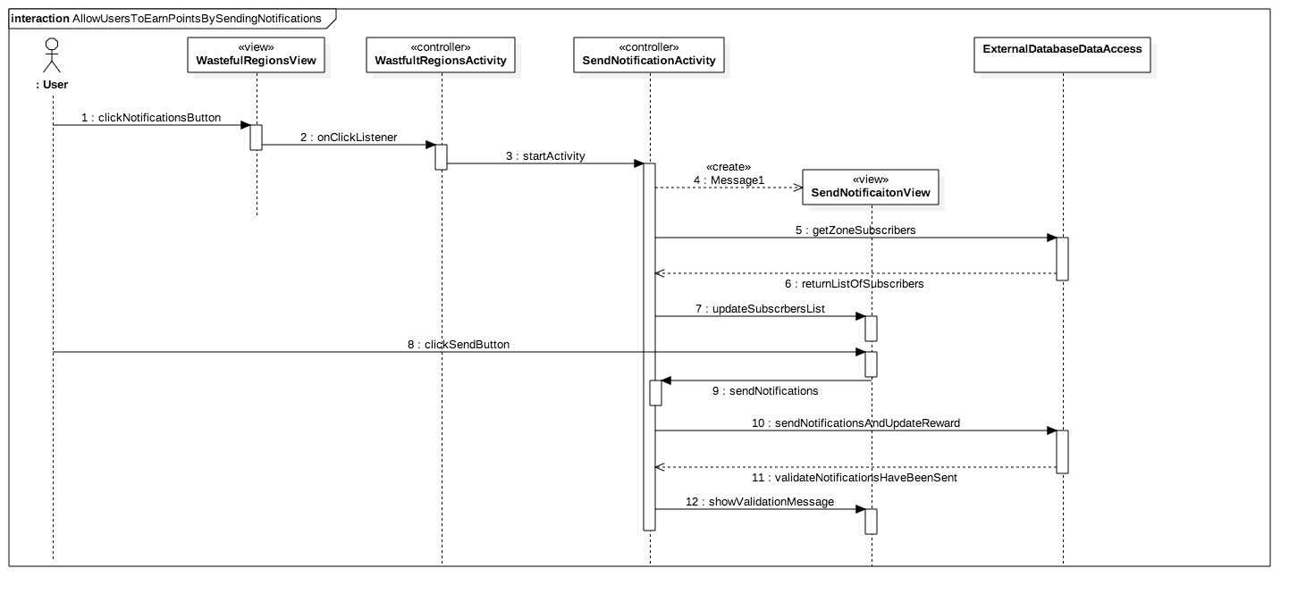

Figure 8 -Allow Users To Earn Points By Sending Notifications

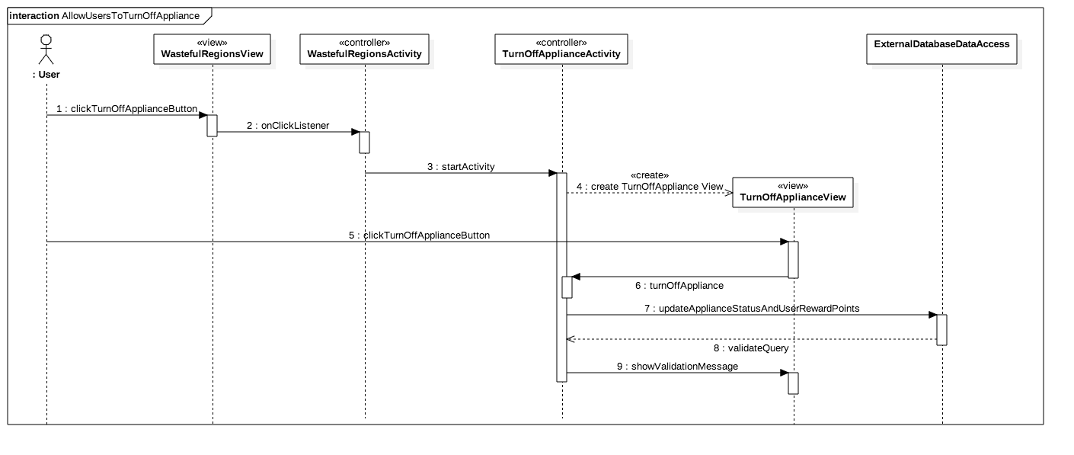

Figure 9 - Allow Users To Turn Off Appliance

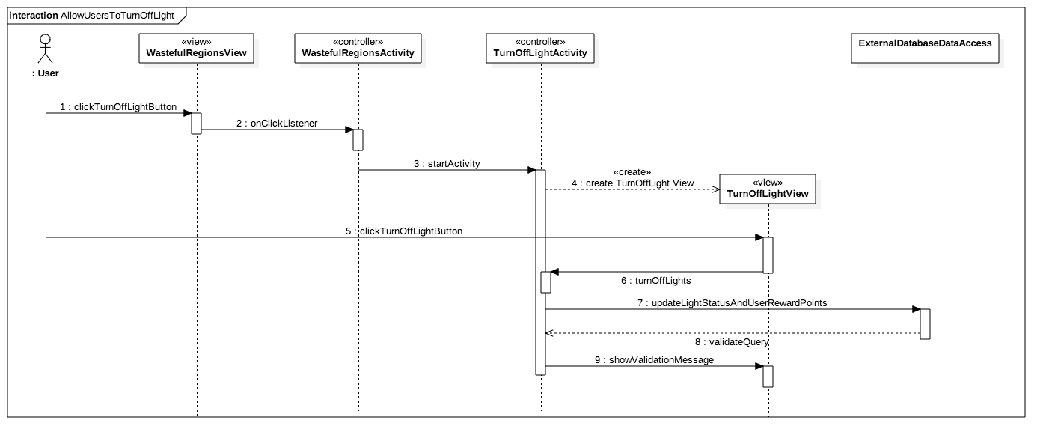

Figure 10 - Allow Users To Turn Off Light

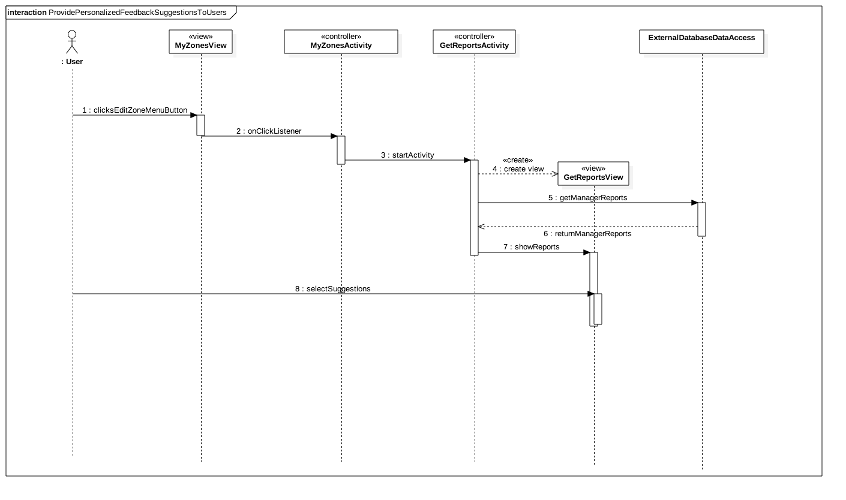

Figure 11 - Provide Personalized Feedback Suggestions To Users

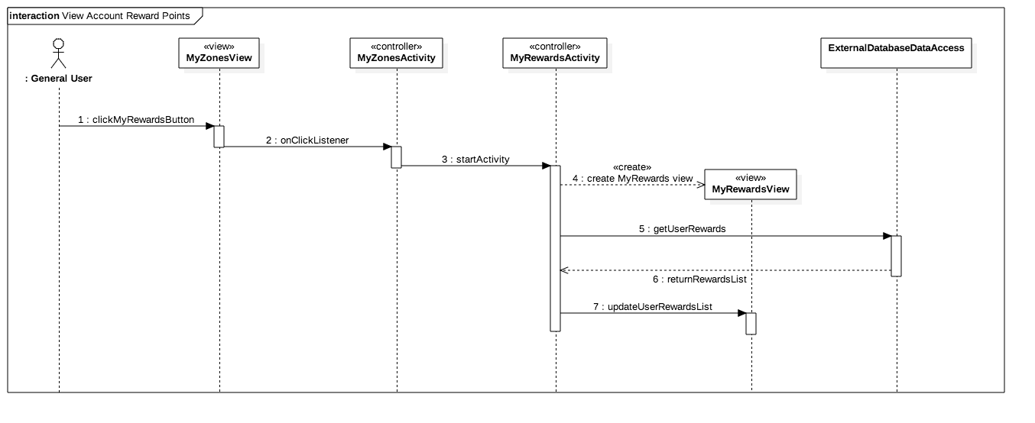

Figure 13 - View Account Reward Points

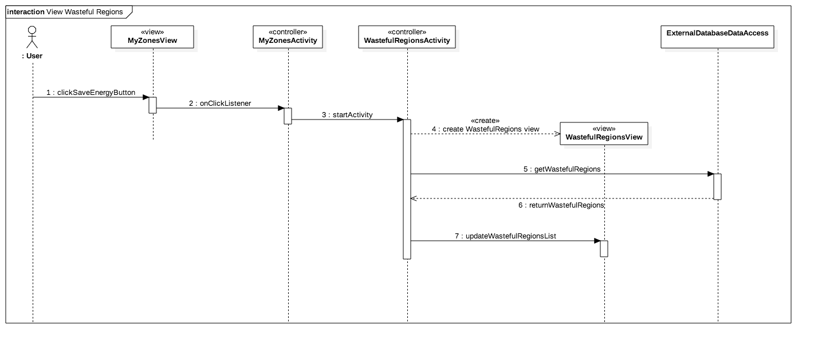

Figure 14 - View Wasteful Regions

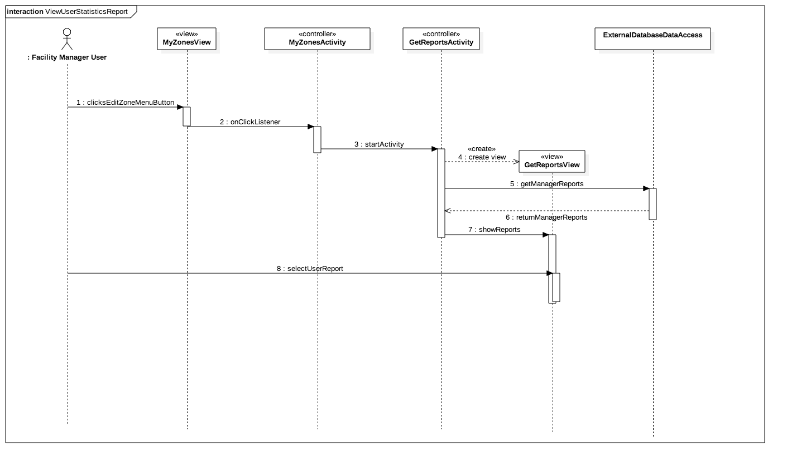

Figure 15 - View User Statistics Report

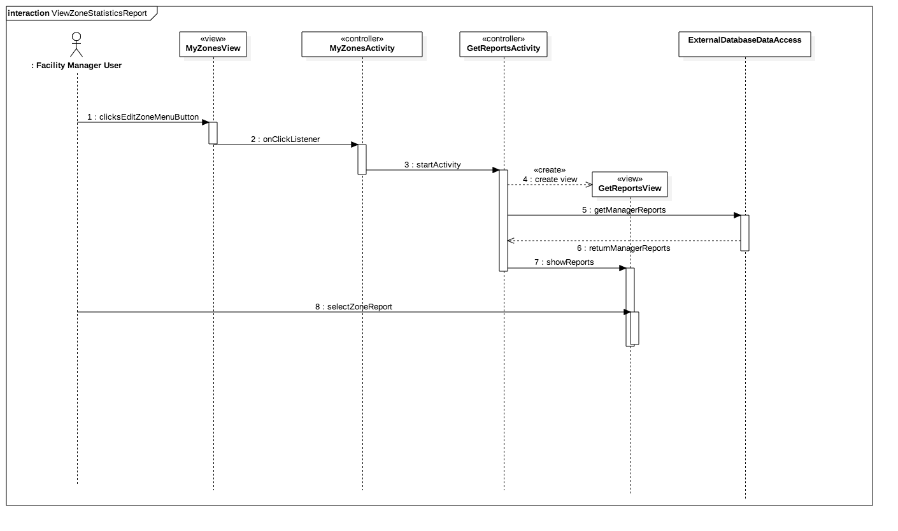

Figure 16 - View Zone Statistics Report

## 

## Appendix B - User Interface Design

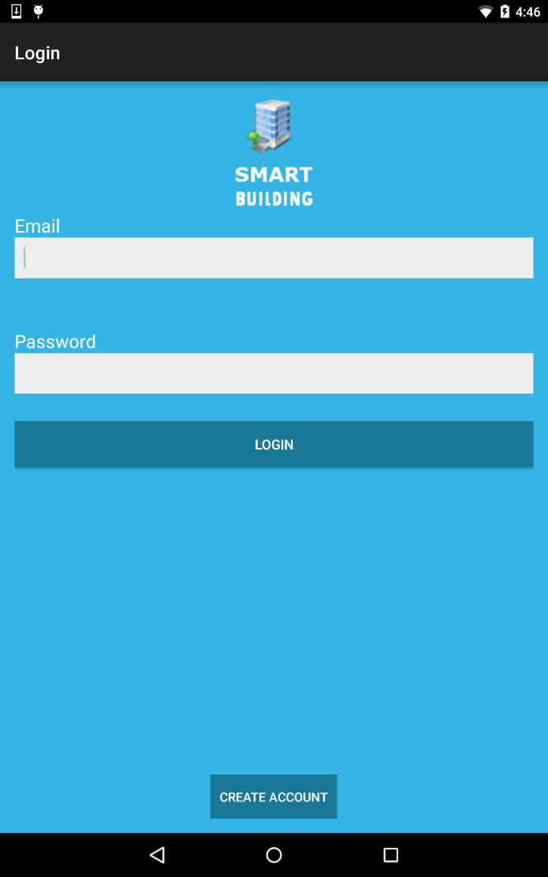

Figure 17 - Login

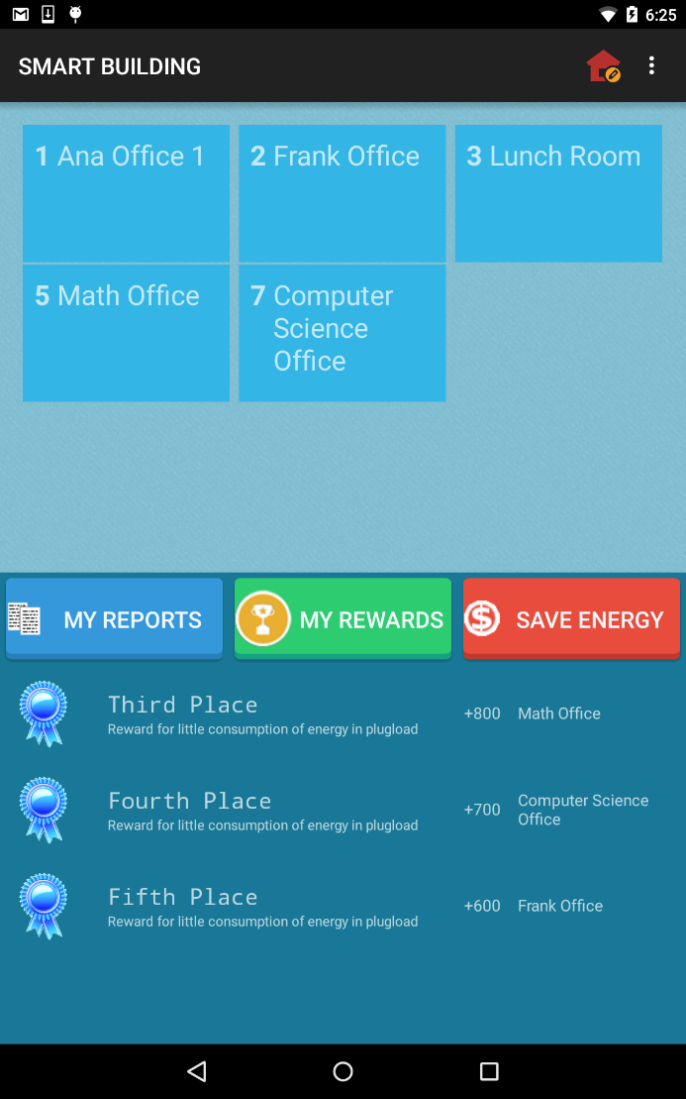

Figure 18 My Zones View

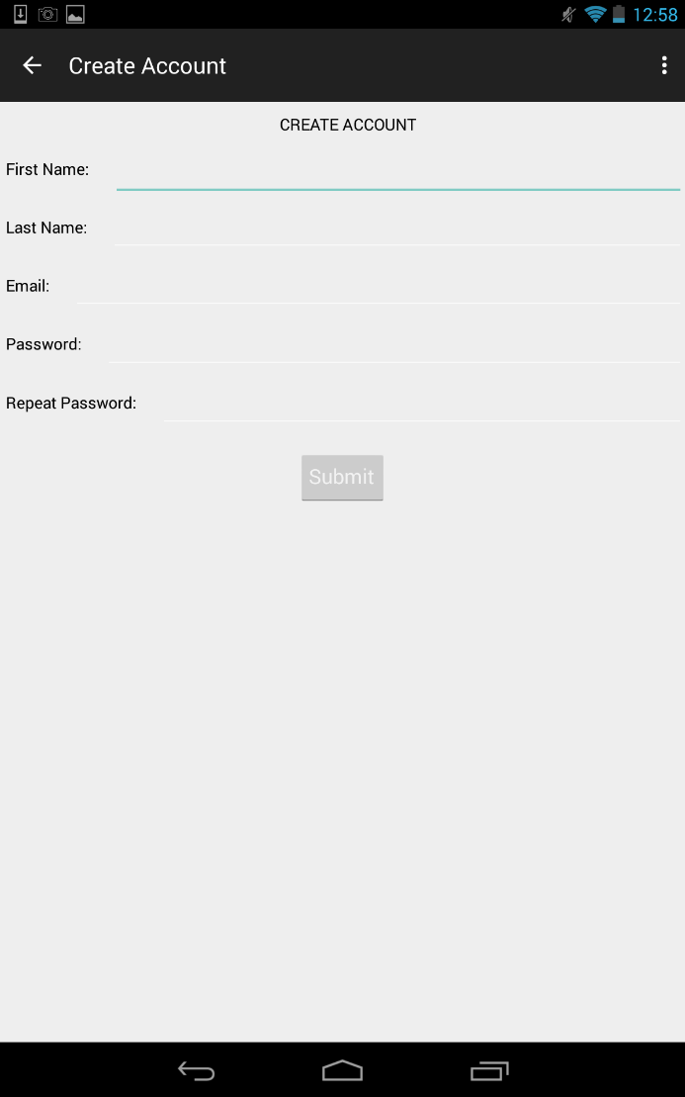

Figure 18 Create Account

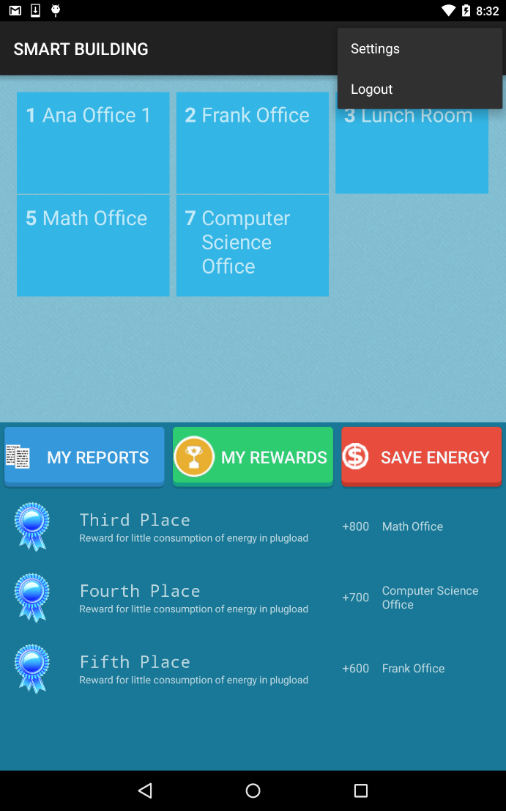

Figure 19 Logout

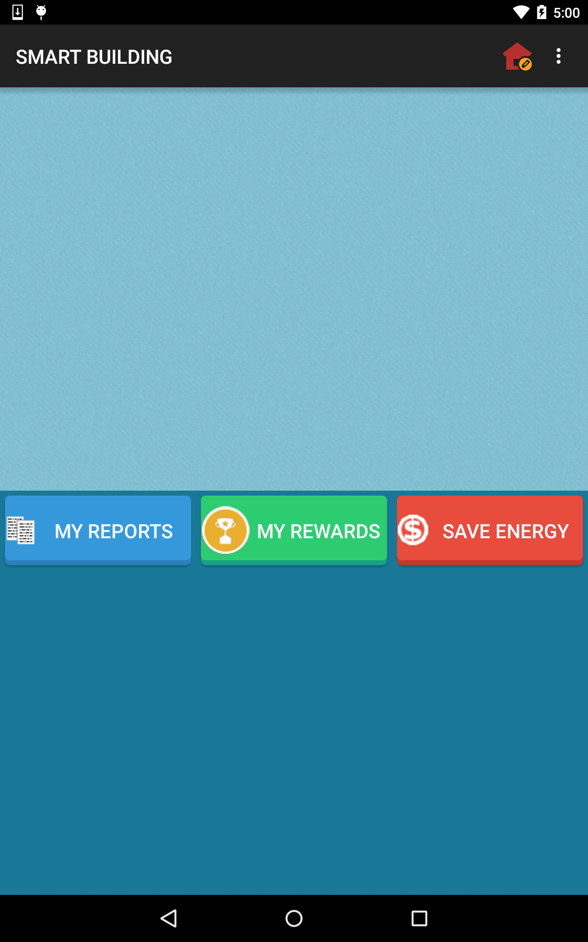 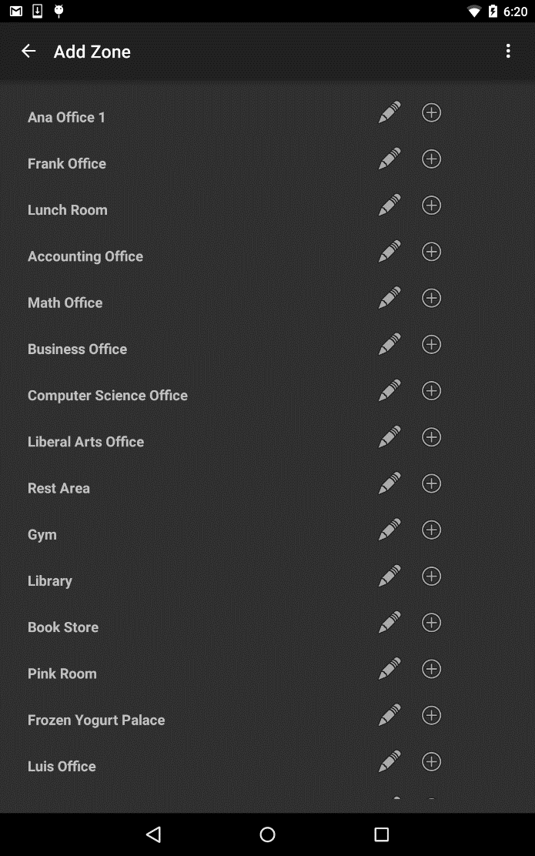

Figure 20 Add Zones

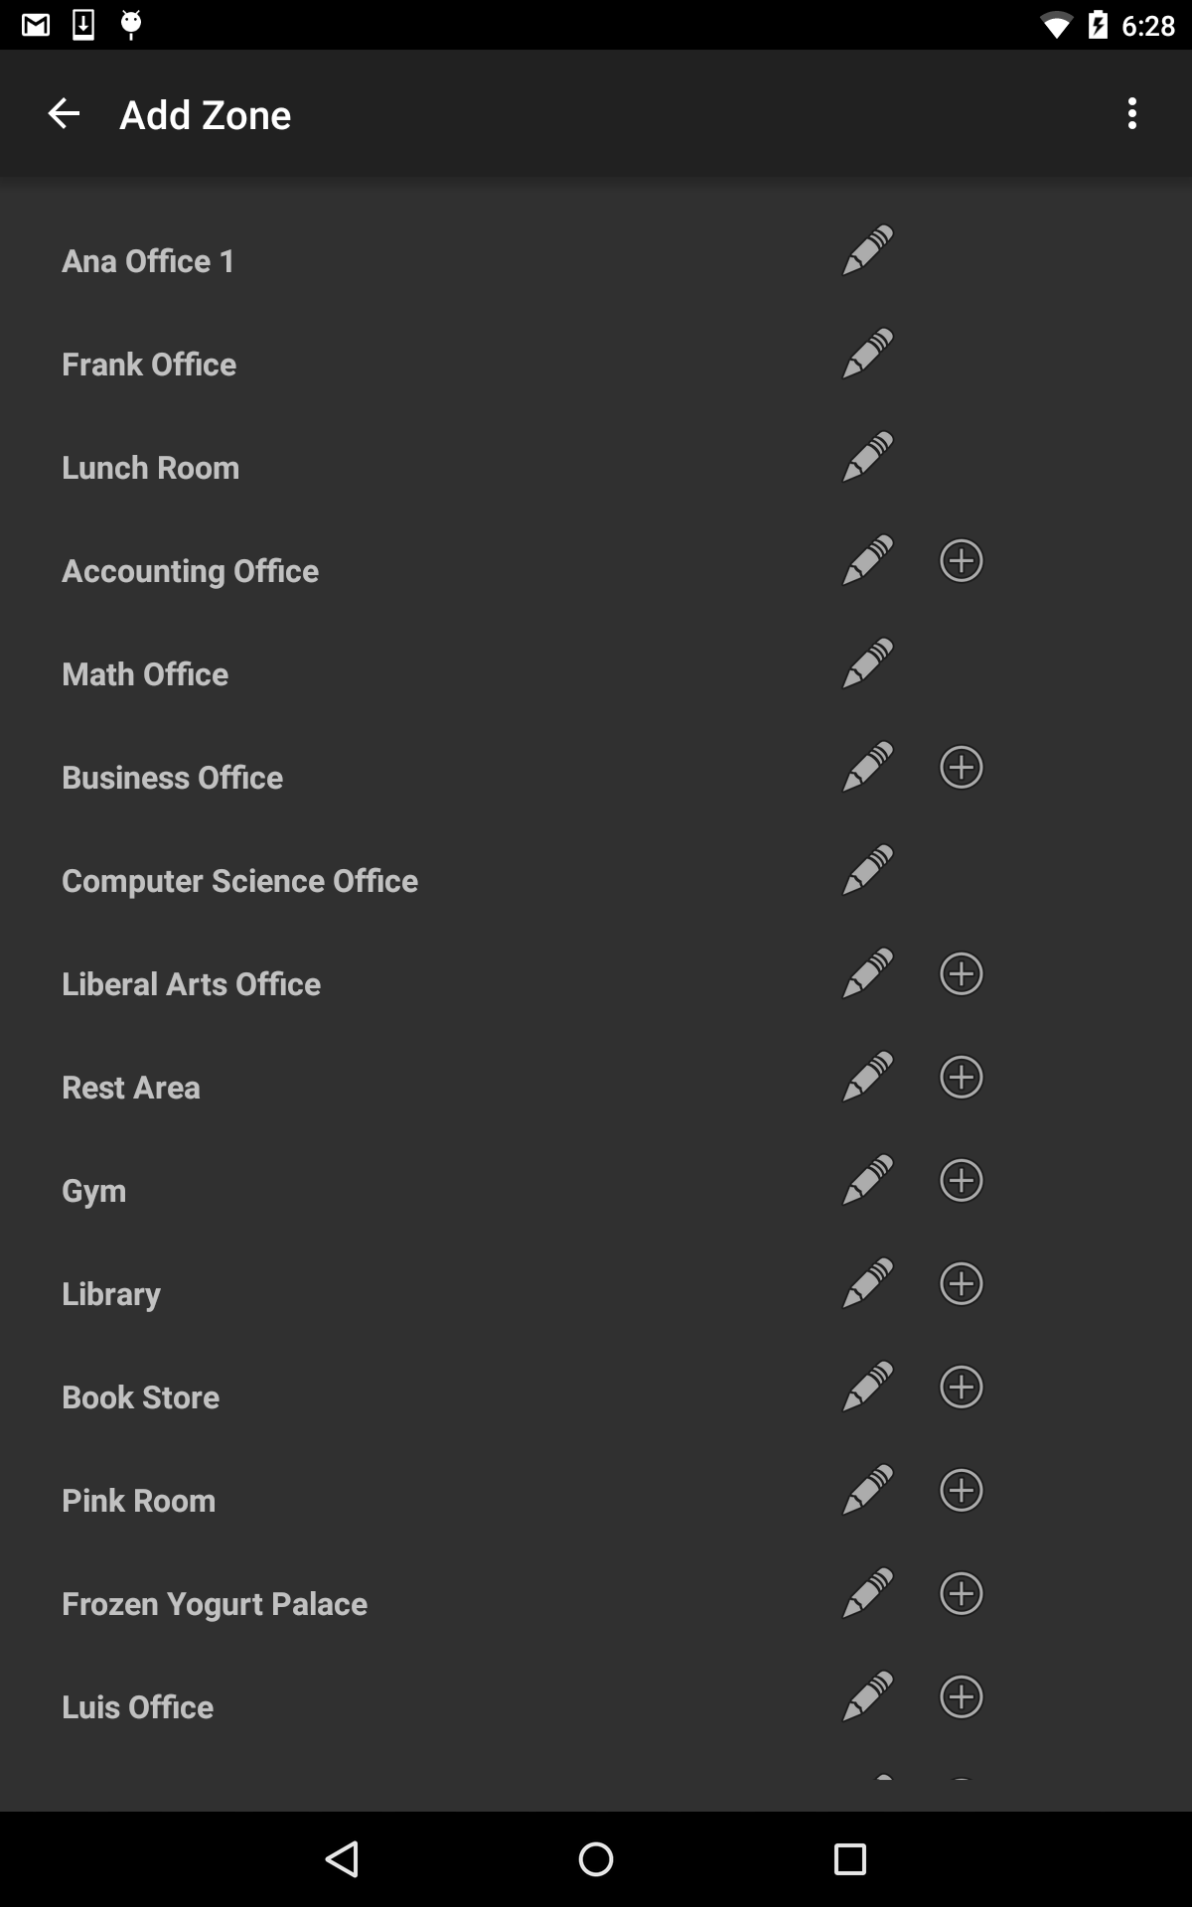 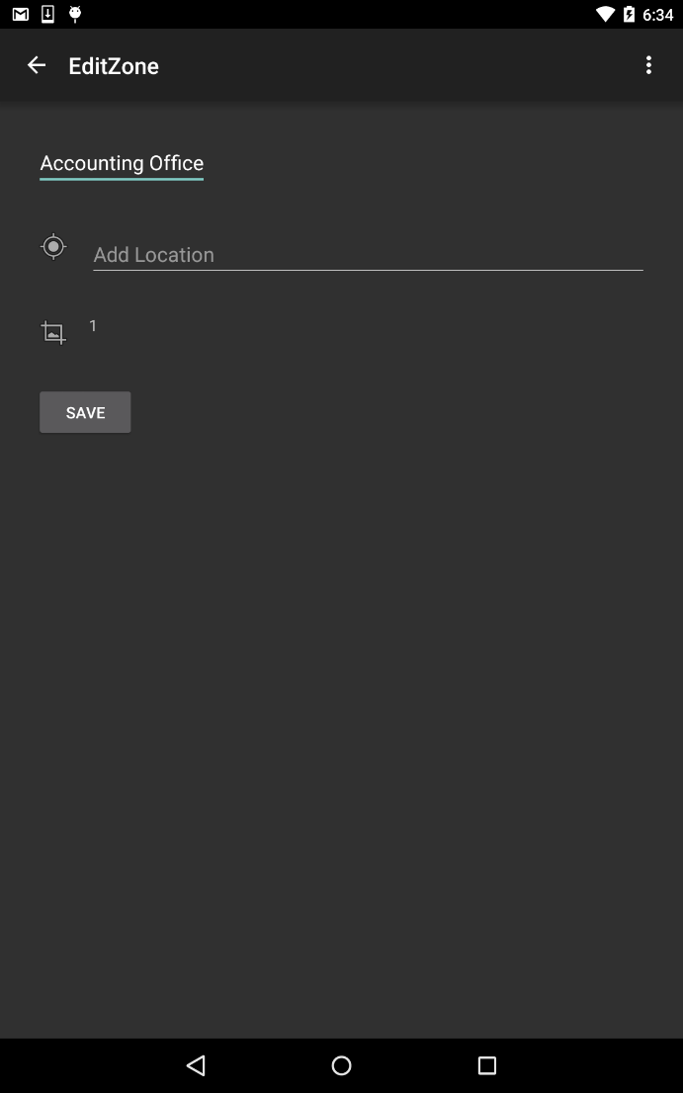

Figure 21 Edit Zone



Figure 22 Select Zone

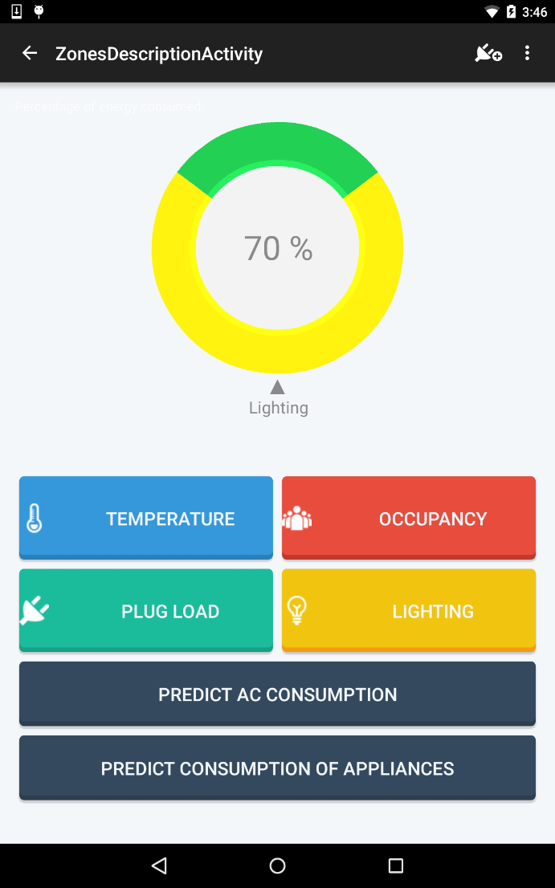

Figure 23 Zone Description

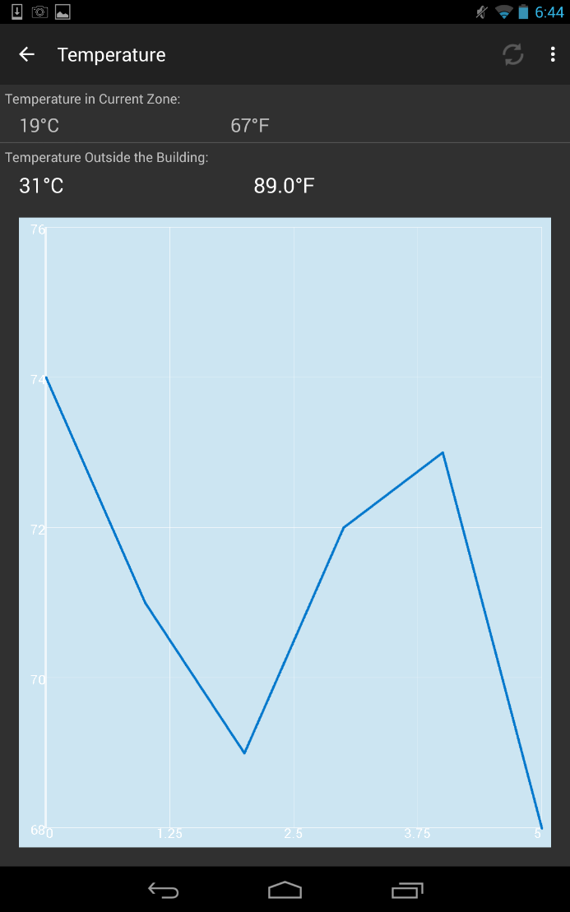

Figure 24 Temperature

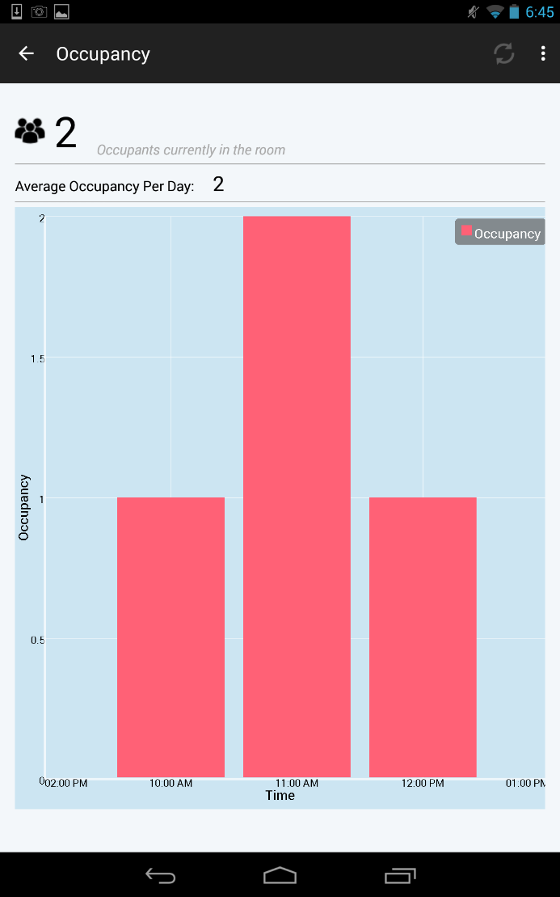

Figure 25 Occupancy

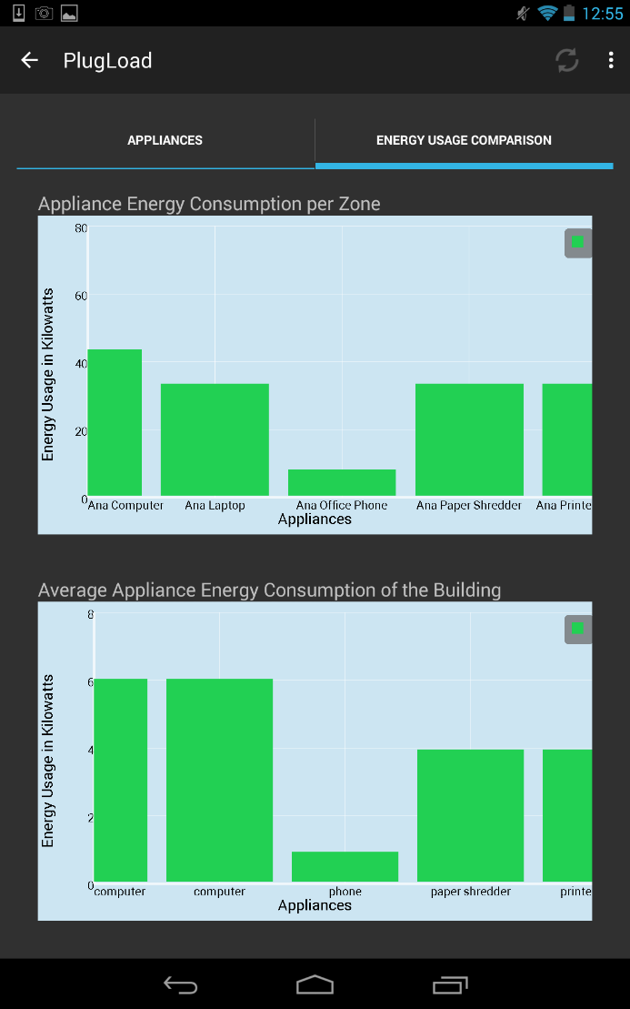

Figure 26 Plugload

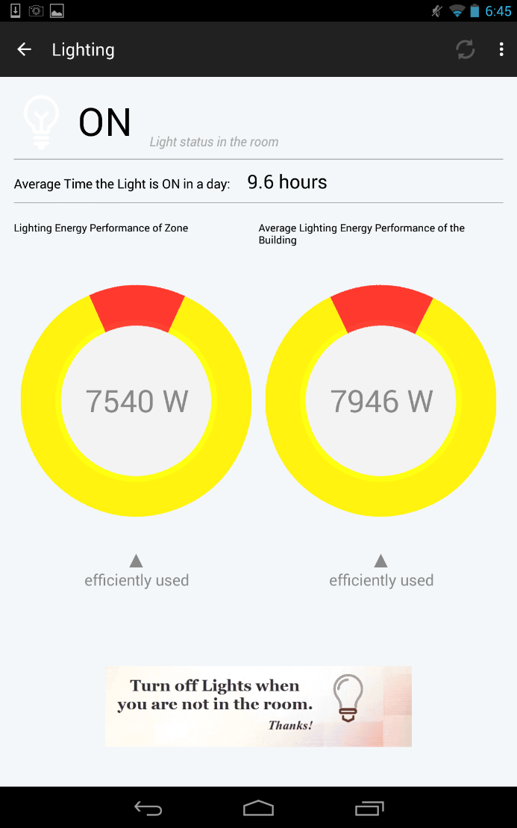

Figure 27 Lighting

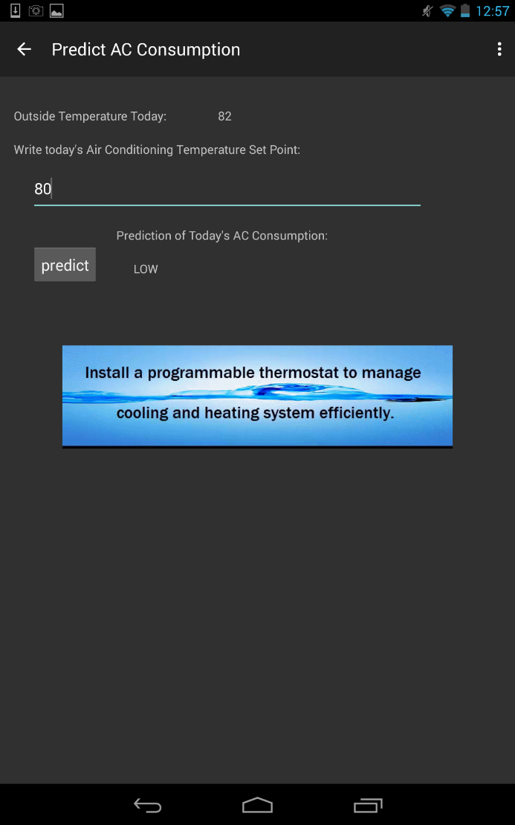

Figure 28 Predictions

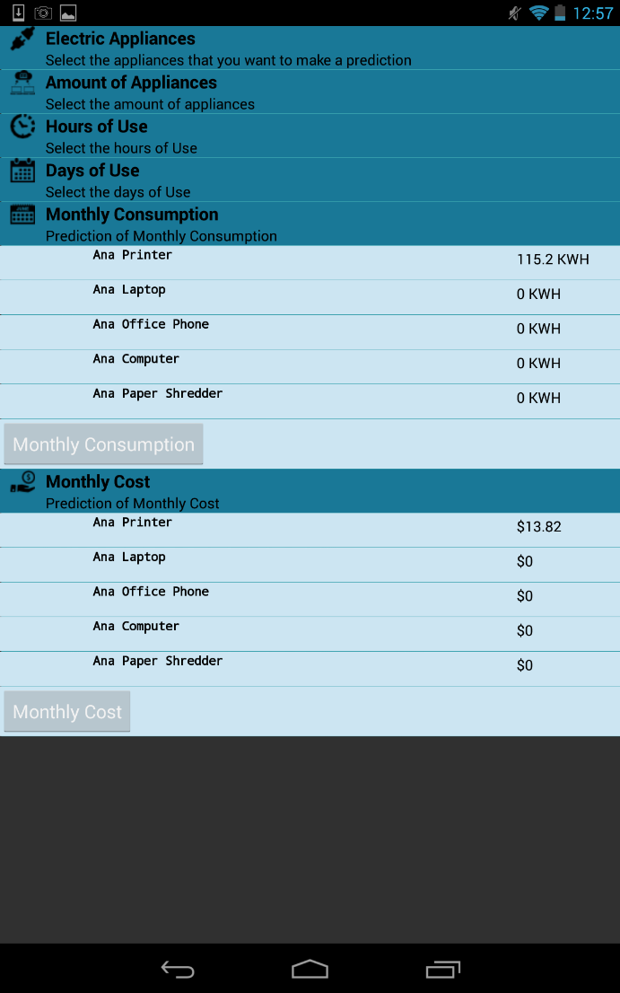

Figure 29 Prediction of Appliance Consumption

 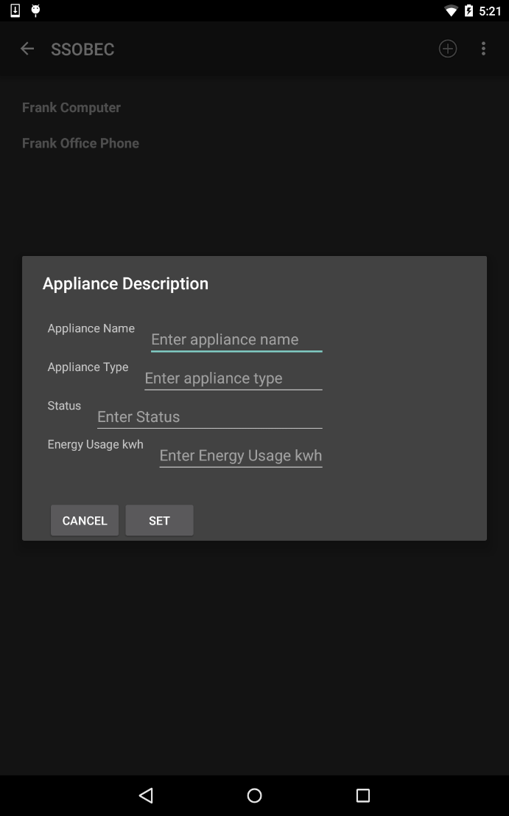

Figure 30 Add Appliance to Zone

 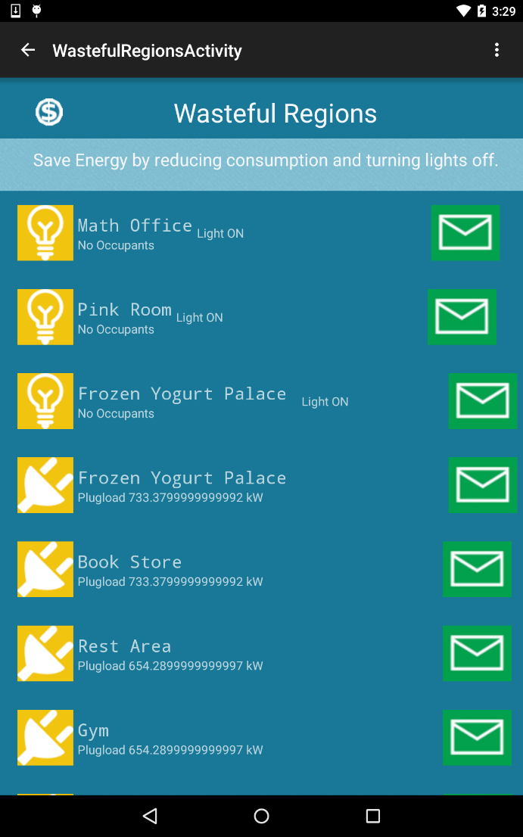

Figure 31 View Wasteful Regions

 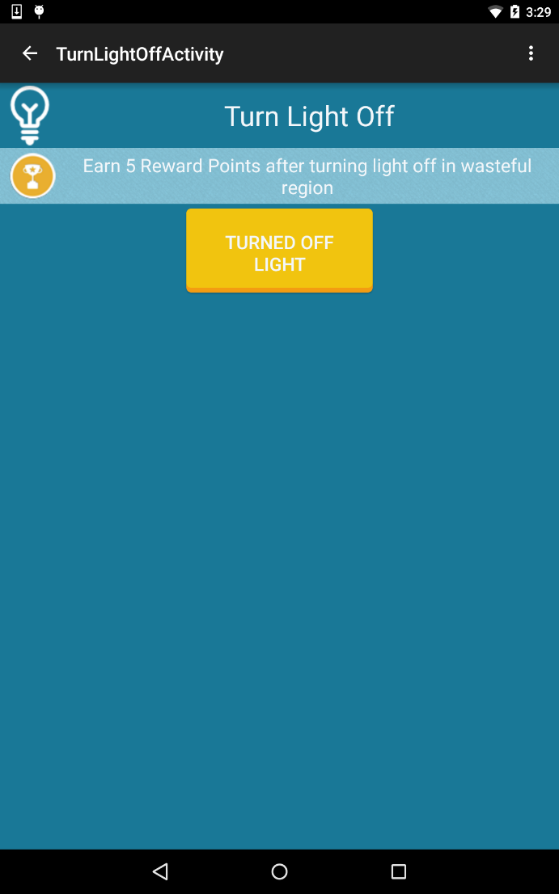

Figure 32 Turn off lights

 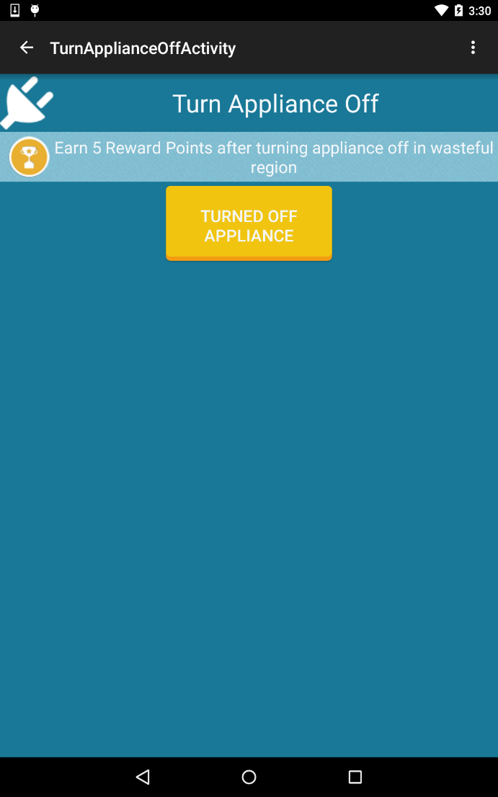

Figure 33 Turn Off Appliance

 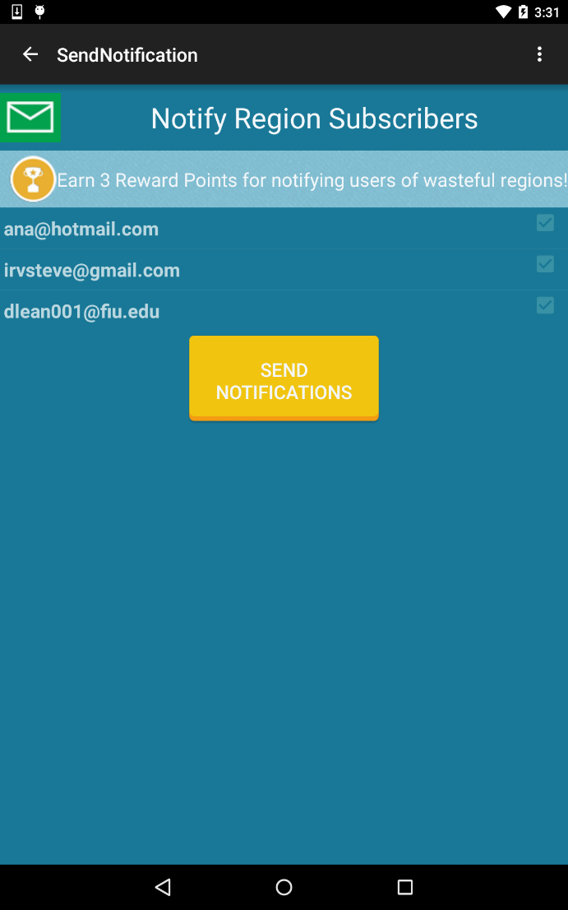

Figure 34 Send Notifications

## 

## Appendix C - Sprint Review Reports

**Sprint 1 Report**

**Date:** May 29th, 2015

**Attendees:** Diana Leante, Irvin Cardenas, Dr. Masoud Sadjadi

**Discussed Topics:**

In this sprint, the team was able to refactor the main view of the SSOBEC application for a general user and develop the view for the role of facility manager which will be carried out by an admin user. We modified the database to include the classification of general user as “user” and facility manager as “admin” user. The Create Account functionality was modified accordingly so that a new user that registers is automatically classified as a general user.

The new functionality allowing a facility manager to create a zone was also developed. This functionality allows an admin user to create a zone within the SSOBEC application without having to access the back-end of the system. When creating a zone, the facility manager can specify the zone name, the zone location, and the number of windows of the zone. The database was modified to reflect these attributes.

Another functionality that was developed was to allow any user to unfollow a zone. This functionality lets a general user or facility manager to make changes to his list of zones by unfollowing a zone that the user has previously added. As a result, the user is no longer linked with this zone and does not view the zone statistics, however the zone is still found in the external database.

During this sprint, the team was not able to finish the documentation related to the added functionalities and some of the functionalities were still in testing phase for the sprint review. As a result, the functionalities were moved to the product backlog for reconsideration in the following sprint. As a team, we underestimated the time needed for documentation and for testing and will reflect these in future sprints.

**Sprint 2 Report**

**Date:** June 12th, 2015

**Attendees:** Diana Leante, Irvin Cardenas, Dr. Masoud Sadjadi, Dr. Leonardo Bobadilla

**Discussed Topics:**

In this sprint, several functionalities were added to the mobile application which significantly improve the capabilities of the app. One of the functionalities implemented was to allow the users to be able to see wasteful regions. The regions were determined to be wasteful based on the plug-load information and on the occupancy and light data indicating that the light was left on in a region with no occupants.

Another functionality implemented was to allow the general user to be able to view his reward points. To accomplish this, it was necessary to create a table for user rewards which contained the user identification, the description of the reward earned, the reward points earned, and time-stamp of when the points were earned. This functionality enables the user to see the summary of his rewards and will allow for the gamification of the application in future sprints, so that users with energy efficient behaviors can be rewarded with points through the Smart Building application.

The new functionality to allow a facility manager to edit a zone was also developed. This addition required the refactoring of the application menu in the MyZones activity and also required redesigning the layout for adding zones. Another feature that was added was to allow general users to add appliances to a zone so that appliance data can be linked to a zone without having to access the backend directly.

During this sprint, the team was able to finish the documentation related to the user stories implemented and the testing phase of all the user stories was carried out to completion within the time estimated. The product backlog was modified to reflect a defect found in viewing the number of occupants of a zone which does not concur with the real time data from the database table.

**Sprint 3 Report**

**Date:** June 26th, 2015

**Attendees:** Diana Leante, Irvin Cardenas, Dr. Masoud Sadjadi, Dr. Leonardo Bobadilla

**Discussed Topics:**

In this sprint, several functionalities were added to the mobile application which significantly improve the capabilities of the app. One of the functionalities implemented was to allow the facility manager to add users to an existing zone and to allow a facility manager to remove user from an existing zone. For this purpose, a User icon was added in the Action Bar to the layout of the facility manager. The facility manager could add or remove a user from a zone by using the email address of the user.

Other functionalities implemented were to allow users to turn off light in wasteful region and earn points and to turn off an appliance in a region and earn points. The two features were made available for any user type. Although the features were implemented, they were not fully tested. During this sprint, the team was able to finish the documentation related to the user stories implemented but the testing phase of two user stories was not finished within the time estimated and the stories were pushed to the following sprint to complete testing..

**Sprint 4 Report**

**Date:** July 10th, 2015

**Attendees:** Diana Leante, Irvin Cardenas, Dr. Masoud Sadjadi, Dr. Leonardo Bobadilla

**Discussed Topics:**

In this sprint, several functionalities were added to the mobile application which enhance the application. Two of the functionalities completed were to allow users to turn off light in wasteful region and earn points and to turn off an appliance in a region and earn points. The regions were determined to be wasteful based on the plug-load information and on the occupancy and light data indicating that the light was left on in a region with no occupants.

Another functionality implemented was to generate user statistics reports. This functionality enables a facility manager to see a graph view of the users organized by reward points earned in saving energy from highest to lowest number of points. The functionality to generate zone statistics reports enables a facility manager to see a graph view of all the zones in the building by energy consumption from highest to lowest and to get statistical information of the zones energy consumption such as the High, Median, Low zones and the Average energy consumption.

The new functionality to allow a user to send notifications to users of a wasteful region was also developed and tested on a local server but could not be implemented of the system serve due access restrictions. As a result, the team decided to research alternate methods to send email notifications. Another feature that was added was to allow users to earn points by sending notifications. This user story was completed and tested successfully. During this sprint, the team was able to finish the documentation related to the user stories implemented.

**Sprint 5 Report**

**Date:** July 24th, 2015

**Attendees:** Diana Leante, Irvin Cardenas, Dr. Masoud Sadjadi, Dr. Leonardo Bobadilla

**Discussed Topics:**

In this sprint, several functionalities were added to the mobile application. One of the functionalities implemented was to allow the users to be able to see his\her ranking by user reward points given for saving energy through the app. The user could also see the ranks of all the users and compare it to his rank.

Another functionality implemented was to allow users to get personalized feedback suggestions. This functionality enables the user to see the summary of his zones energy consumption and compares it to the average energy consumption in the building. Suggestions on which zones the user should focus on are also listed based on the users’ zones that are above the average energy consumption.

The functionality of Sending Notifications was finished and the alternated method was implemented to complete the feature. During this sprint, the team was able to finish the documentation related to the user stories and also the user manual was created and the screenshots for the previous version were updated.

## 

## Appendix D - Sprint Retrospective Reports

**Sprint 1 Retrospective**

**Date:** May 29th, 2015

**Attendees:** Diana Leante, Irvin Cardenas

**Discussed Topics:**

The team was able to meet on time and attend all scheduled meetings without issues. We were able to develop the functionalities requested by the product owners and refactor the design to meet the new requirements. We had to fix some minor bugs in the system including changing the use of data that was hard-coded from the previous version. Some of these design issues were not accounted for in our planning for the sprint.

We were not able to finish the documentation for the added functionalities. As a result, the functionalities were moved to the product backlog to be considered for the following sprint although they were fully developed. We underestimated the time needed to finish documentation and also the time needed for testing since we ran into several issues that required refactoring code and modifying functions which used hard-coded data. In order to improve in future sprints, we will take into account the time for documentation and the time for testing and reflect it in our user stories.

**Sprint 2 Retrospective**

**Date:** June 12th, 2015

**Attendees:** Diana Leante, Irvin Cardenas

**Discussed Topics:**

The team was able to meet on time and attend all meetings as scheduled. We were able to complete all the user stories in the estimated time and finalize the testing of all functionalities. The team was also able to work on the final project documentation and finish the documentation for the user stories. A defect was found in viewing the occupancy of a region selected which was not showing the data in real time based on the database information. As a result, the team agreed to reflect this issue in the product backlog to be addressed in future sprints.

**Sprint 3 Retrospective**

**Date:** June 26th, 2015

**Attendees:** Diana Leante, Irvin Cardenas

**Discussed Topics:**

The team was able to meet on time and attend all meetings as scheduled. We were able to complete the user stories of Allowing the Facility Manager to Add users to an existing Zone and Allowing the Facility Manager to Remove users from an existing Zone in the estimated time. The testing of two user stories was not finalized so the team agreed to push these user stories to the following sprint since the testing time left was estimated to only a few hours. The team agreed to review the estimates for testing functionalities and assign more time to prevent from coming up short in future sprints.

**Sprint 4 Retrospective**

**Date:** July 10th, 2015

**Attendees:** Diana Leante, Irvin Cardenas

**Discussed Topics:**

The team was able to meet on time and attend all meetings as scheduled. We were able to complete all the user stories in the estimated time except the Send Notifications story. The email server to send email notifications was setup and tested locally and was working properly on the local setup. However, there appears to be some restrictions on the FIU server that prevent the user of the server to send email notifications directly through the FIU application server. We also do not have access to change one of the configuration files of our server in order to send the email notifications successfully. The team agreed to explore alternative methods to be able to send the notifications in case we are not granted the authorization to change the configuration file of the server.

**Sprint 5 Retrospective**

**Date:** July 24th, 2015

**Attendees:** Diana Leante, Irvin Cardenas

**Discussed Topics:**

The team was able to meet on time and attend all meetings as scheduled. We were able to complete all the user stories in the estimated time and finalize the testing of all functionalities. The team was also able to work on the final project documentation and finish the documentation for the user stories. The email server was successfully setup using an alternate method since we could not send email notifications directly through the FIU application server due to authorization restrictions of the university and also restrictions with the type of email accounts that could be used to send notifications. The application’s User Manual was completed and the app logo and name was changed to appear as “Smart Building” which reflects more the name of the system rather than the previous “My Zones”.

# **References**

* + 1. <http://www.agilemodeling.com/artifacts/userStory.htm#Introduction>